

**AMERICAN INTERNATIONAL UNIVERSITY**

**BANGLADESH**

**COURSE:** INTRODUCTION TODATABASE

**PROJECT TITLE**: UE-COMMERCE MANAGEMENT SYSTEMU **.**

**GROUP NUMBER**: 03 **SEMESTER:** FALL 20-21

**COURSE TEACHER**:SIFAT RAHMAN AHONA **SECTION:** L

|  |  |
| --- | --- |
| **ID** | **NAME** |
| 19-41766-3 | Saidul Mursalin Khan |
| 19-41749-3 | Md Abu Sufian |
| 19-41764-3 | Sumit Kanti Sarker |
| 20-41973-1 | Abzana Sultan ira |

Table of Contents

30TIntroduction30T 3

30TCase Study30T 4

30TER Diagram30T 5

30TNormalization30T 6

30TTotal Table30T 17

30TFinal Table30T 18

30TSchema Diagram30T 19

30TTable Creation30T 20

30TData Insertion30T 37

30TQuery Writing30T 54

30TRelational Algebra30T 69

30TConclusion30T 70

# Introduction

E-commerce Management System is an application, refers to the buying and selling of goods or services online, and the transfer of money and data to execute these transactions. For the peoples, it is making life easier. For the management point of view, the admin will able to control the E-commerce system by having all the reports to hand and able to see the records of each customers.

This application will help the Ecommerce to do all functionalities more accurately and faster way by online. E-commerce Management System is often used to refer to the sale of physical products online and improves efficiency of commercial activities. The application can help products ordering from different category and brands and also there are many more functionalities like-

* To store customer information
* Control order and services
* Payments
* Add or remove products based on categories and brands
* Helps admin to control each part of the E-commerce system

The main goal is to maintain the E-commerce system’s functions in an effective and accurate manner. This system will help orders to maintain day to day records.

# Case Study

Title: E-commerce management system

Ecommerce, also known as electronic commerce or internet commerce, refers to the buying and selling of goods or services using the internet, and the transfer of money and data to execute these transactions. Ecommerce is often used to refer to the sale of physical products online, but it can also describe any kind of commercial transaction that is facilitated through the internet.

In our e-commerce management system there has a system administrator who can control the system. The administrator’s name, email, phone no, address, username and password is stored in the system. The system administrator can add and remove products. There has many types of products. The products are defined with name, id and type. Those products has many categories. The categories has different category id and category name. These category also has different brands and those are identified by brand id and brand name. Customer’s name, address, phone number, email, username, password and customer id are stored in the system. Customers are identified with customer id. A customer can login to the system with username and password. Customer can add a product to the wish list in order to buy the product later. Wish list need wish list id, product id and product name. Customer can add any product to the cart. Cart has product quantity, total cost, product id, serial number, per product price and cart id. Customer has an order option from where he/she can order a product from the cart by doing the payment. Order has order id, date of order, product id and total cost of the product. The payment option has amount, payment type (card and cash on delivery) and payment id. After the payment the order will processed.

That is how our e-commerce management system will work.

# ER Diagram

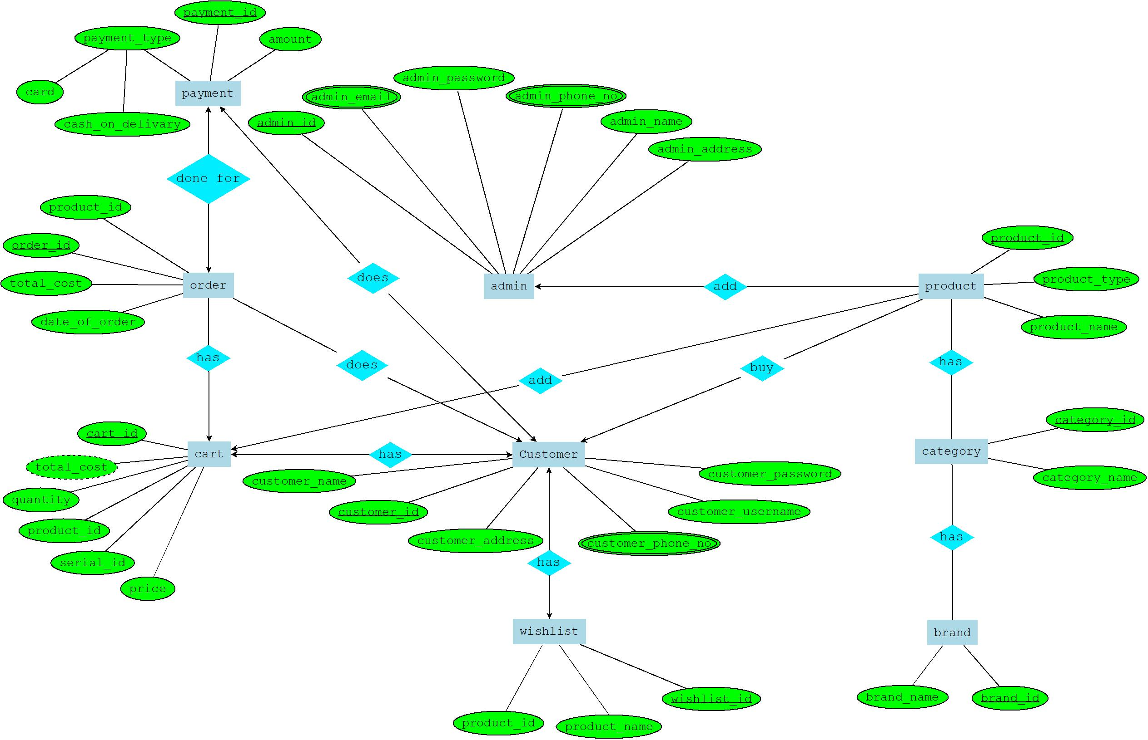

# Normalization

**admin add product**

**UNF :**

add(Uadmin_idU, admin_email, admin_password, admin_phone_no, admin_name, admin_address, Uproduct_idU, product_type, product_name)

**1NF:**

admin_email, admin_phone_no multivalued attribute.

**2NF:**

1. Uadmin_idU, admin_email, admin_password, admin_phone_no, admin_name, admin_address
2. Uproduct_idU, product_type, product_name, **admin_id**

**3NF:**

1. Uadmin_idU, admin_email, admin_password, admin_phone_no, admin_name, admin_address
2. Uproduct_idU, **p_id**, **admin_id**
3. Up_idU, product_type, product_name

**Table:**

1. Uadmin_idU, admin_password, admin_phone_no, admin_name, **address_id**
2. Uaddress_idU, admin_address, admin_email.
3. Uproduct_idU, product_type, product_name**, admin_id.**

**product has category**

**UNF :**

has(Uproduct_idU, product_type, product_name, Ucategory_idU, category_name)

**1NF:**

No multivalued attribute.

**2NF:**

1. Uproduct_idU, product_type, product_name
2. Ucategory_idU, category_name
3. **product_id, category_id**

**3NF:**

1. Uproduct_idU, product_type, product_name
2. Ucategory_idU, category_name
3. **product_id, category_id**

No transitive dependency.

**Table:**

1. Uproduct_idU, product_type, product_name
2. Ucategory_idU, category_name
3. **product_id, category_id**

**category has brand**

**UNF :**

has(Ucategory_idU, category_name, Ubrand_idU, brand_name)

**1NF:**

No multivalued attribute.

**2NF:**

1. Ucategory_idU, category_name
2. Ubrand_idU, brand_name
3. **category_id, brand_id**

**3NF:**

1. Ucategory_idU, category_name
2. Ubrand_idU, brand_name
3. **category_id, brand_id**

No transitive dependency.

**Table:**

1. Ucategory_idU, category_name
2. Ubrand_idU, brand_name
3. **category_id, brand_id**

**customer has wishlist**

**UNF :**

has(Ucustomer_idU, customer_name, customer_address, customer_phone_no, customer_username, customer_password, Uwishlist_idU, customer_id, product_id, product_name)

**1NF:**

customer_phone_no multivalued attribute.

**2NF:**

1. Ucustomer_idU, customer_name, customer_address, customer_phone_no, customer_username, customer_password.
2. Uwishlist_idU, product_id, **customer_id.**

**3NF:**

1. Ucustomer_idU, customer_name, customer_address, customer_phone_no, customer_username, customer_password.
2. Uwishlist_idU, product_id, **customer_id.**

No transitive dependency.

**Table:**

1. Ucustomer_idU, customer_name, customer_address, customer_phone_no, customer_username, customer_password.
2. Uwishlist_idU, product_id, **customer_id.**

**customer buy product**

**UNF :**

buy(Ucustomer_idU, customer_name, customer_address, customer_phone_no, customer_username, customer_password, Uproduct_idU, product_type, product_name)

**1NF:**

customer_phone_no multivalued attribute.

**2NF:**

1. Ucustomer_idU, customer_name, customer_address, customer_phone_no, customer_username, customer_password
2. Uproduct_idU, product_type, product_name, **customer_id**

**3NF:**

1. Ucustomer_idU, customer_name, customer_address, customer_phone_no, customer_username, customer_password
2. Uproduct_idU, product_type, product_name, **customer_id.**

No transitive dependency.

**Table:**

1. Ucustomer_idU, customer_name, customer_address, customer_phone_no, customer_username, customer_password
2. Uproduct_idU, product_type, product_name, **customer_id.**

**customer has cart**

**UNF :**

has(Ucustomer_idU, customer_name, customer_address, customer_phone_no, customer_username, customer_password, Ucart_idU, total_cost, quantity, product_id, serial_id, price)

**1NF:**

customer_phone_no multivalued attribute.

**2NF:**

1. Ucustomer_idU, customer_name, customer_address, customer_phone_no, customer_username, customer_password
2. Ucart_idU, total_cost, quantity, product_id, serial_id, price, **customer_id**

**3NF:**

1. Ucustomer_idU, customer_name, customer_address, customer_phone_no, customer_username, customer_password
2. Ucart_idU, product_id, serial_id, **customer_id**, **pq_id**
3. Upq_idU, price, quantity, total_cost

**Table:**

1. Ucustomer_idU, customer_name, customer_address, customer_phone_no, customer_username, customer_password
2. Ucart_idU, product_id, serial_id, **customer_id**, **pq_id**
3. Upq_idU, price, quantity, total_cost.

**customer does payment**

**UNF :**

does(Ucustomer_idU, customer_name, customer_address, customer_phone_no, customer_username, customer_password, Upayment_idU, card, cash_on_delivary, amount)

**1NF:**

customer_phone_no multivalued attribute.

**2NF:**

1. Ucustomer_idU, customer_name, customer_address, customer_phone_no, customer_username, customer_password
2. Upayment_idU, card, cash_on_delivary, amount, **customer_id**

**3NF:**

1. Ucustomer_idU, customer_name, customer_address, customer_phone_no, customer_username, customer_password
2. Upayment_idU, card, cash_on_delivary, amount, **customer_id**

No transitive dependency.

**Table:**

1. Ucustomer_idU, customer_name, customer_address, customer_phone_no, customer_username, customer_password
2. Upayment_idU, card, cash_on_delivary, amount, **customer_id**

**customer does order**

**UNF :**

does(Ucustomer_idU, customer_name, customer_address, customer_phone_no, customer_username, customer_password, Uorder_idU, total_cost, product_id, date_of_order)

**1NF:**

customer_phone_no multivalued attribute.

**2NF:**

1. Ucustomer_idU, customer_name, customer_address, customer_phone_no, customer_username, customer_password
2. Uorder_idU, total_cost, product_id, date_of_order, **customer_id**

**3NF:**

1. Ucustomer_idU, customer_name, customer_address, customer_phone_no, customer_username, customer_password
2. Uorder_idU, total_cost, product_id, date_of_order, **customer_id**

No transitive dependency.

**Table:**

1. Ucustomer_idU, customer_name, customer_address, customer_phone_no, customer_username, customer_password
2. Uorder_idU, total_cost, product_id, date_of_order, **customer_id**

**product add cart**

**UNF :**

add(Uproduct_idU, product_type, product_name, Ucart_idU, total_cost, quantity, product_id, serial_id, price)

**1NF:**

No multivalued attribute.

**2NF:**

1. Uproduct_idU, product_type, product_name, **cart_id**
2. Ucart_idU, total_cost, quantity, product_id, serial_id, price

**3NF:**

1. Uproduct_idU, product_type, product_name, **cart_id**
2. Ucart_idU, product_id, serial_id, **pq_id**
3. Upq_idU, total_cost, quantity, price

**Table:**

1. Uproduct_idU, product_type, product_name, **cart_id**
2. Ucart_idU, product_id, serial_id, **pq_id**
3. Upq_idU, total_cost, quantity, price.

**cart has order**

**UNF :**

has(Ucart_idU, total_cost, quantity, product_id, serial_id, price, Uorder_idU, total_cost, product_id, date_of_order)

**1NF:**

No multivalued attribute.

**2NF:**

1. Ucart_idU, total_cost, quantity, product_id, serial_id, price
2. Uorder_idU, total_cost, product_id, date_of_order, **cart_id**

**3NF:**

1. Ucart_idU, product_id, serial_id, **pq_id**
2. Uorder_idU, total_cost, product_id, date_of_order, **cart_id**
3. Upq_idU, price, quantity, total_cost

**Table:**

1. Ucart_idU, product_id, serial_id, **pq_id**
2. Uorder_idU, total_cost, product_id, date_of_order, **cart_id**
3. Upq_idU, price, quantity, total_cost.

**order done for payment**

**UNF :**

done for(Uorder_idU, total_cost, product_id, date_of_order, Upayment_idU, card, cash_on_delivary, amount)

**1NF:**

No multivalued attribute.

**2NF:**

1. Uorder_idU, total_cost, product_id, date_of_order
2. Upayment_idU, card, cash_on_delivary, amount, **order_id**

**3NF:**

1. Uorder_idU, total_cost, product_id, date_of_order
2. Upayment_idU, card, cash_on_delivary, amount, **order_id**

No transitive dependency.

**Table:**

1. Uorder_idU, total_cost, product_id, date_of_order
2. Upayment_idU, card, cash_on_delivary, amount, **order_id**

# Total Table

1. Uadmin_idU, admin_password, admin_phone_no, admin_name, **address_id**
2. Uaddress_idU, admin_address, admin_email
3. Uproduct_idU, product_type, product_name**, admin_id**
4. SU~~product_id~~U~~, product_type, product_name~~
5. Ucategory_idU, category_name
6. **product_id, category_id**
7. SU~~category_id~~U~~, category_name~~
8. Ubrand_idU, brand_name
9. **category_id, brand_id**
10. Ucustomer_idU, customer_name, customer_address, customer_phone_no, customer_username, customer_password
11. Uwishlist_idU, product_id, **customer_id**
12. SU~~customer_id~~U~~, customer_name, customer_address, customer_phone_no, customer_username, customer_password~~
13. Uproduct_idU, product_type, product_name, **customer_id**
14. SU~~customer_id~~U~~, customer_name, customer_address, customer_phone_no, customer_username, customer_password~~
15. Ucart_idU, product_id, serial_id, **customer_id**, **pq_id**
16. SU~~pq_id~~U~~, price, quantity, total_cost~~
17. SU~~customer_id~~U~~, customer_name, customer_address, customer_phone_no, customer_username, customer_password~~
18. Upayment_idU, card, cash_on_delivary, amount, **customer_id**
19. SU~~customer_id~~U~~, customer_name, customer_address, customer_phone_no, customer_username, customer_password~~
20. Uorder_idU, total_cost, product_id, date_of_order, **customer_id**
21. Uproduct_idU, product_type, product_name, **cart_id**
22. SU~~cart_id~~U~~, product_id, serial_id,~~ **~~pq_id~~**
23. SU~~pq_id~~U~~, total_cost, quantity, price~~
24. SU~~cart_id~~U~~, product_id, serial_id,~~ **~~pq_id~~**
25. Uorder_idU, total_cost, product_id, date_of_order, **cart_id**
26. Upq_idU, price, quantity, total_cost
27. SU~~order_id~~U~~, total_cost, product_id, date_of_order~~
28. Upayment_idU, card, cash_on_delivary, amount, **order_id**

# Final Table

1. Uadmin_idU, admin_password, admin_phone_no, admin_name, **address_id**
2. Uaddress_idU, admin_address, admin_email
3. Uproduct_idU, product_type, product_name**, admin_id**
4. Ucategory_idU, category_name
5. **product_id, category_id**
6. Ubrand_idU, brand_name
7. **category_id, brand_id**
8. Ucustomer_idU, customer_name, customer_address, customer_phone_no, customer_username, customer_password
9. Uwishlist_idU, product_id, **customer_id**
10. Uproduct_idU, product_type, product_name, **customer_id**
11. Ucart_idU, product_id, serial_id, **customer_id**, **pq_id**
12. Upq_idU, price, quantity, total_cost
13. Upayment_idU, card, cash_on_delivary, amount, **customer_id**
14. Uorder_idU, total_cost, product_id, date_of_order, **customer_id**
15. Uproduct_idU, product_type, product_name, **cart_id**
16. Uorder_idU, total_cost, product_id, date_of_order, **cart_id**
17. Upayment_idU, card, cash_on_delivary, amount, **order_id**

# Schema Diagram

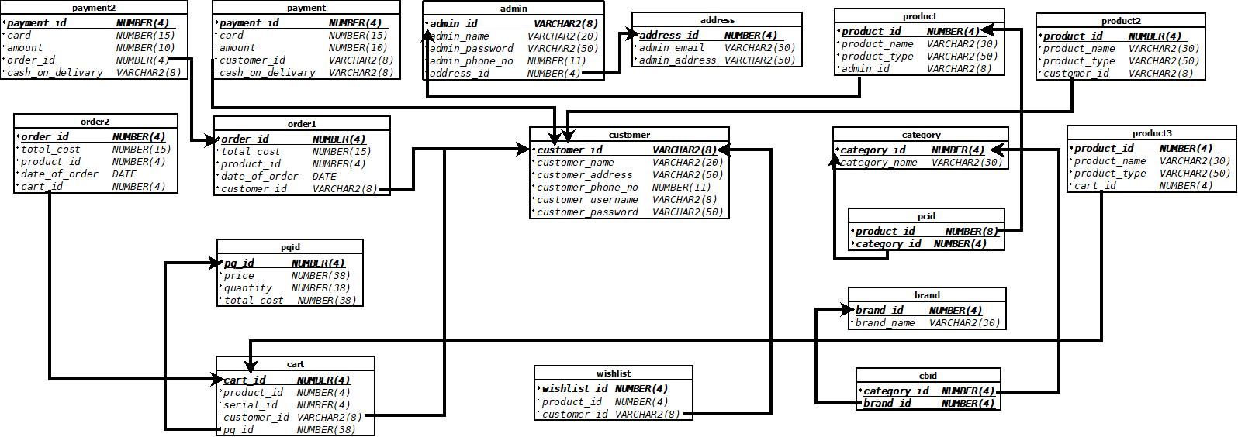

# Table Creation

**Table : admin**

CREATE TABLE admin

(

admin_id VARCHAR2(8) NOT NULL,

admin_name VARCHAR2(20) NOT NULL,

admin_password VARCHAR2(50) NOT NULL,

admin_phone_no NUMBER(11) NOT NULL,

address_id NUMBER(4) NOT NULL,

CONSTRAINT admin_PK PRIMARY KEY(admin_id),

CONSTRAINT admin_FK FOREIGN KEY(address_id) REFERENCES address(address_id)

);

DESCRIBE admin;

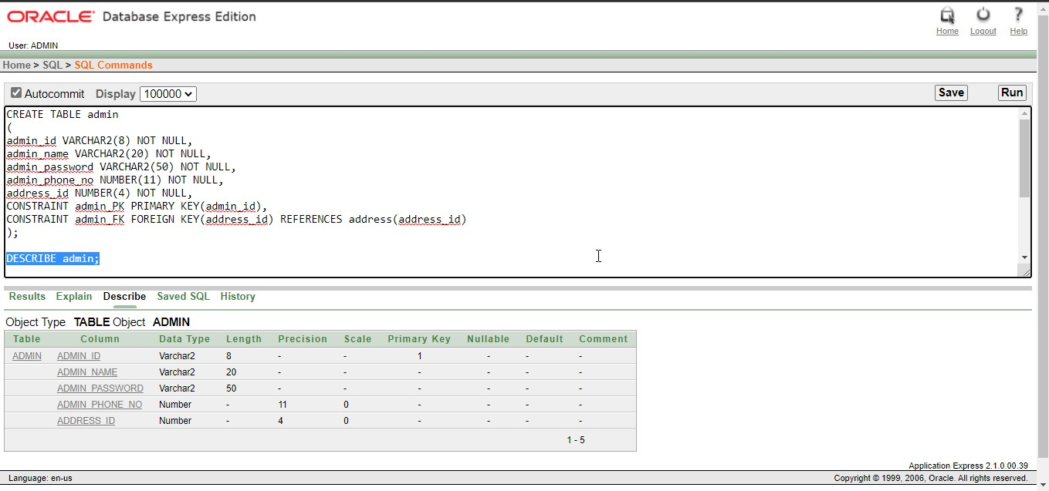

**Table : address**

CREATE TABLE address

(

address_id NUMBER(4) NOT NULL,

admin_email VARCHAR2(30) UNIQUE,

admin_address VARCHAR2(50) NOT NULL,

CONSTRAINT address_PK PRIMARY KEY(address_id)

);

DESCRIBE address;

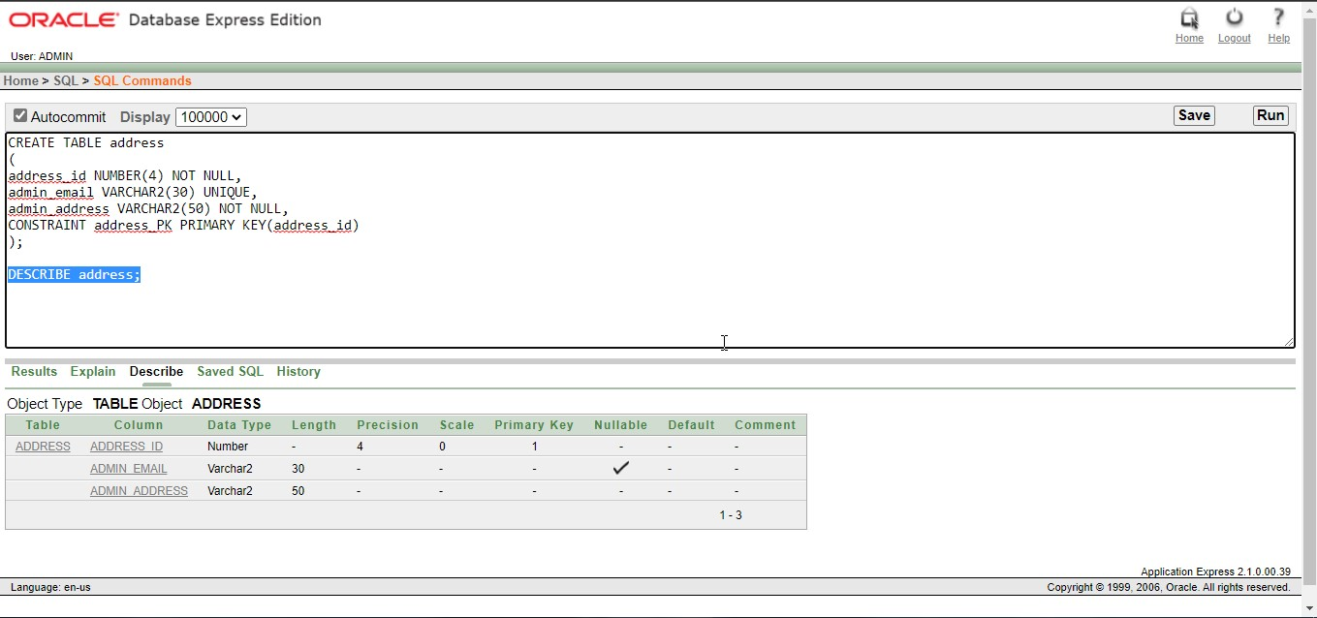

**Table : product**

CREATE TABLE product

(

product_id NUMBER(4) NOT NULL,

product_name VARCHAR2(30) UNIQUE,

product_type VARCHAR2(50) NOT NULL,

admin_id VARCHAR2(8) NOT NULL,

CONSTRAINT product_PK PRIMARY KEY(product_id),

CONSTRAINT product_FK FOREIGN KEY(admin_id) REFERENCES admin(admin_id)

);

DESCRIBE product;

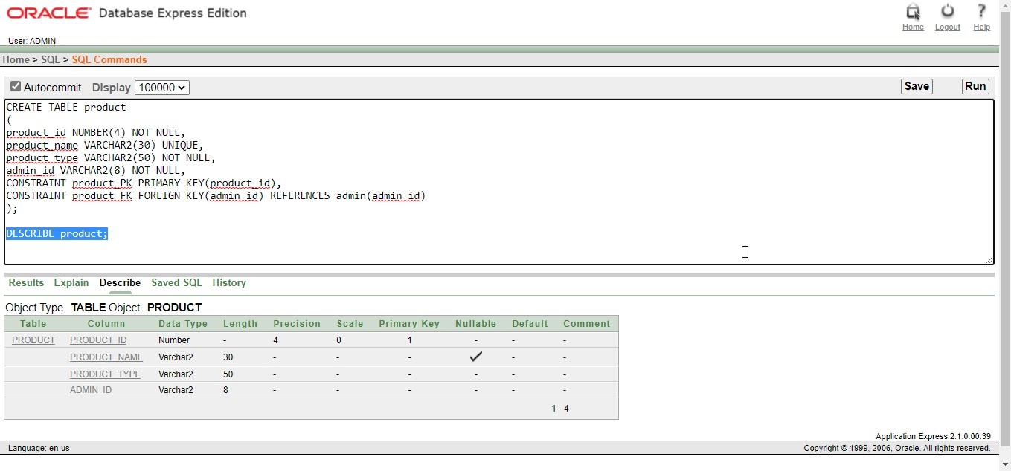

**Table : category**

CREATE TABLE category

(

category_id NUMBER(4) NOT NULL,

category_name VARCHAR2(30) UNIQUE,

CONSTRAINT category_PK PRIMARY KEY(category_id)

);

DESCRIBE category;

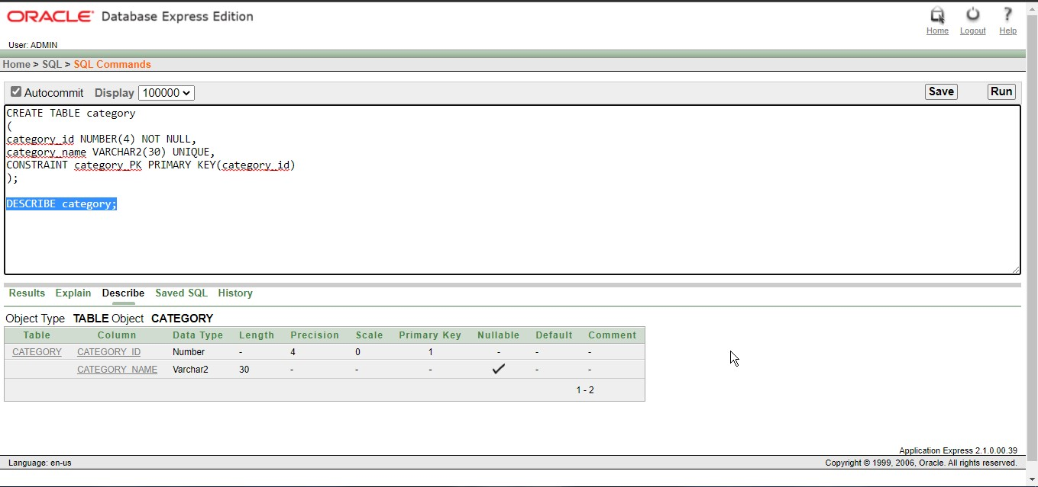

**Table : pcid**

CREATE TABLE pcid (

product_id NUMBER(8),

category_id NUMBER(4),

CONSTRAINT pcid_PK PRIMARY KEY(product_id, category_id),

CONSTRAINT pcid_p_FK FOREIGN KEY(product_id) REFERENCES product(product_id),

CONSTRAINT pcid_c_FK FOREIGN KEY(category_id) REFERENCES category(category_id)

);

DESCRIBE pcid;

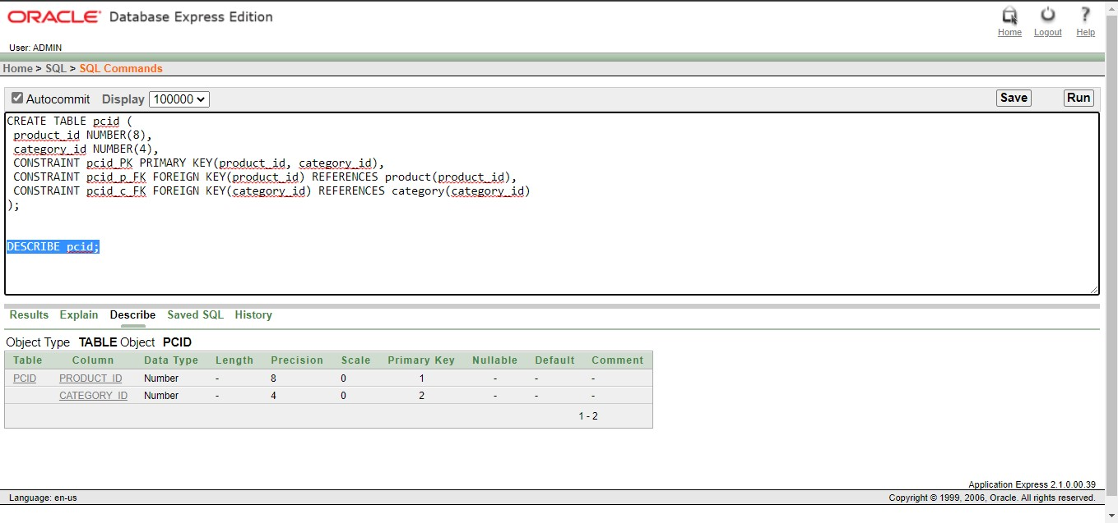

**Table : brand**

CREATE TABLE brand

(

brand_id NUMBER(4) NOT NULL,

brand_name VARCHAR2(30) UNIQUE,

CONSTRAINT brand_PK PRIMARY KEY(brand_id)

);

DESCRIBE brand;

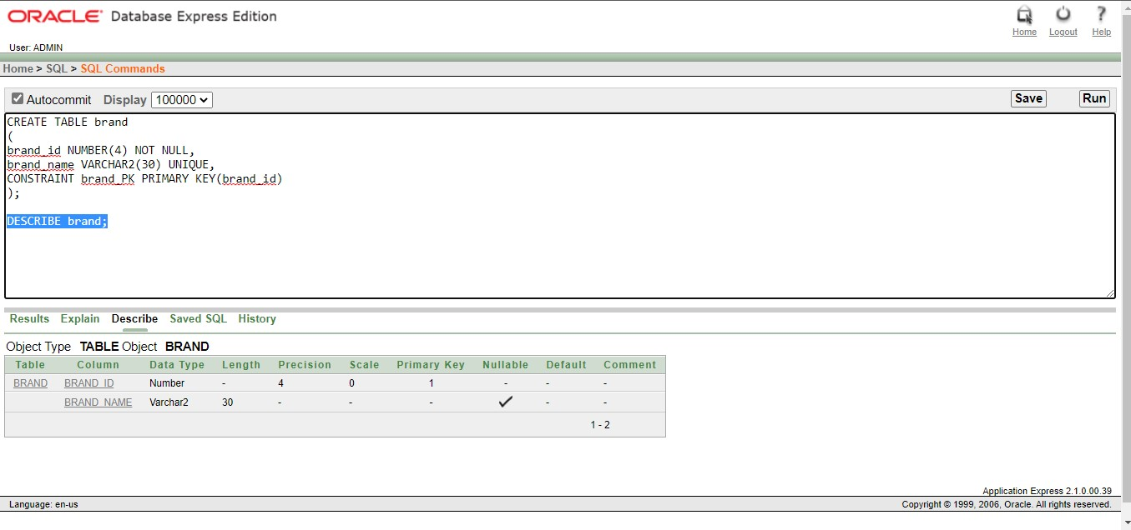

**Table : cbid**

CREATE TABLE cbid

(

category_id NUMBER(4),

brand_id NUMBER(4),

CONSTRAINT cbid_PK PRIMARY KEY(category_id, brand_id),

CONSTRAINT cbid_c_FK FOREIGN KEY(category_id) REFERENCES category(category_id),

CONSTRAINT cbid_b_FK FOREIGN KEY(brand_id) REFERENCES brand(brand_id)

);

DESCRIBE cbid;

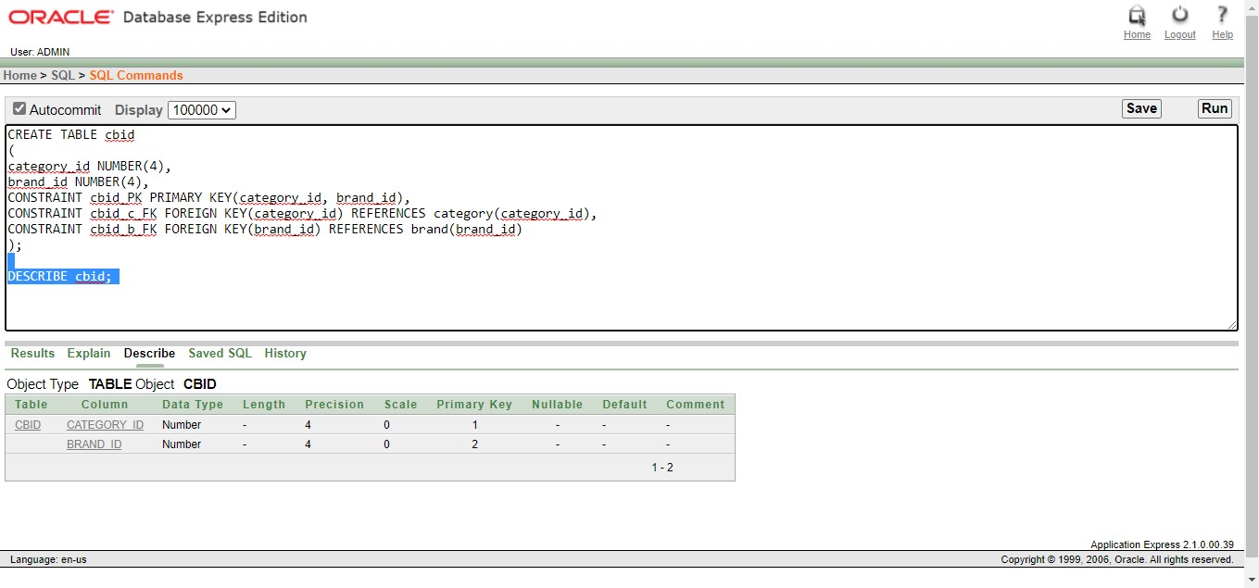

**Table : customer**

CREATE TABLE customer

(

customer_id VARCHAR2(8) NOT NULL,

customer_name VARCHAR2(20) NOT NULL,

customer_address VARCHAR2(50) NOT NULL,

customer_phone_no NUMBER(11) NOT NULL,

customer_username VARCHAR2(8) NOT NULL,

customer_password VARCHAR2(50) NOT NULL,

CONSTRAINT customer_PK PRIMARY KEY(customer_id),

CONSTRAINT customer_unique UNIQUE (customer_id, customer_name)

);

DESCRIBE customer;

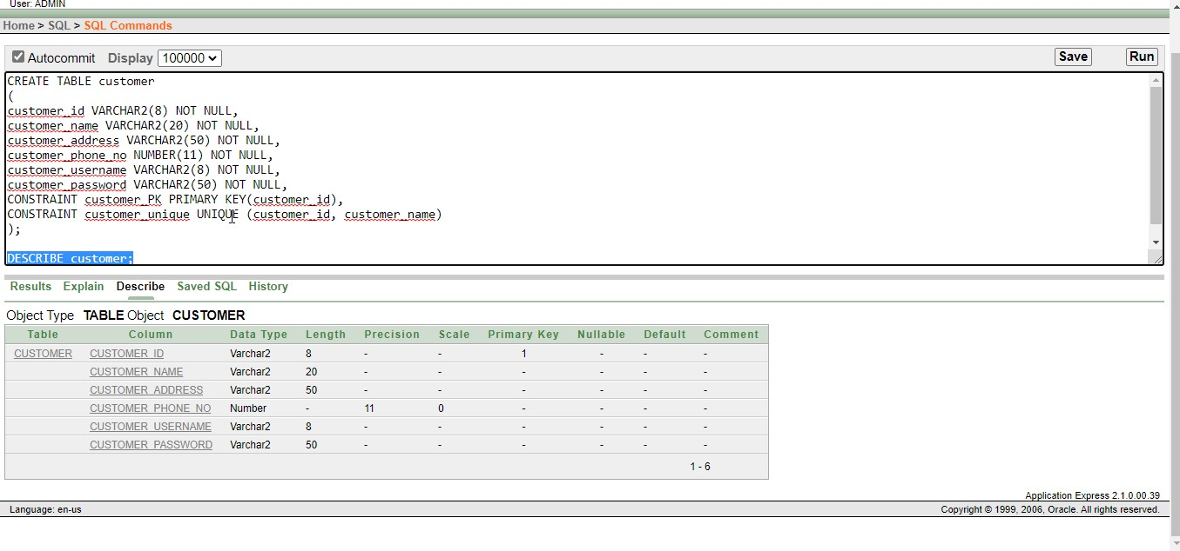

**Table : wishlist**

CREATE TABLE wishlist

(

wishlist_id NUMBER(4) NOT NULL,

product_id NUMBER(4) NOT NULL,

customer_id VARCHAR2(8) NOT NULL,

CONSTRAINT wishlist_PK PRIMARY KEY(wishlist_id),

CONSTRAINT wishlist_unique UNIQUE (wishlist_id, product_id, customer_id)

);

DESCRIBE wishlist;

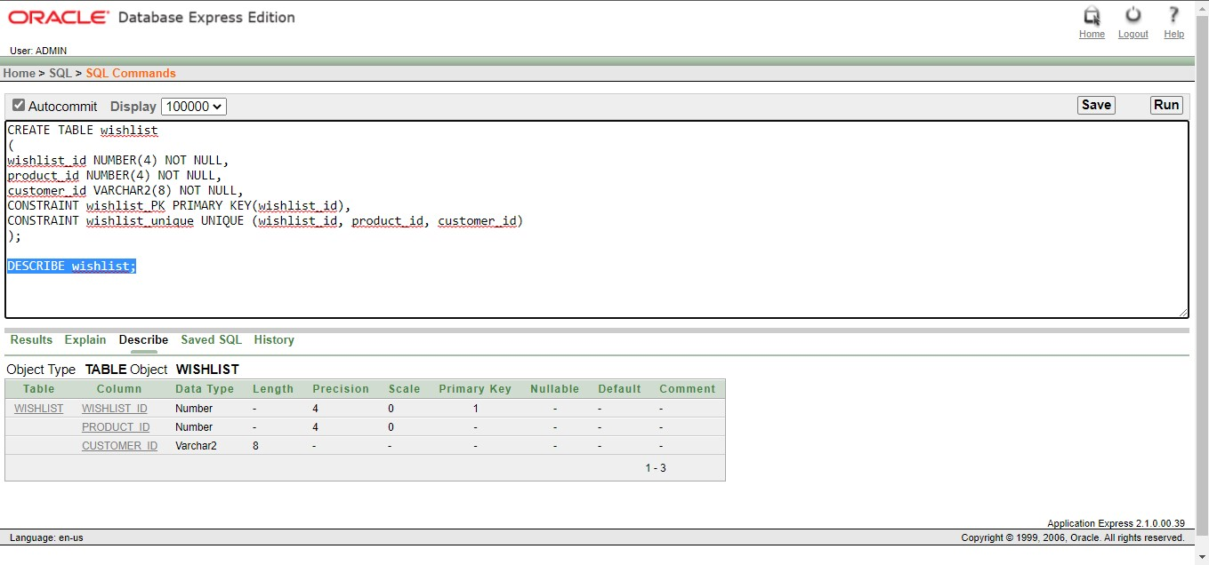

**Table : product2**

CREATE TABLE product2

(

product_id NUMBER(4) NOT NULL,

product_name VARCHAR2(30) UNIQUE,

product_type VARCHAR2(50) NOT NULL,

customer_id VARCHAR2(8) NOT NULL,

CONSTRAINT product2_PK PRIMARY KEY(product_id),

CONSTRAINT product2_FK FOREIGN KEY(customer_id) REFERENCES customer(customer_id),

CONSTRAINT product2_unique UNIQUE (product_id, product_name, product_type)

);

DESCRIBE product2;

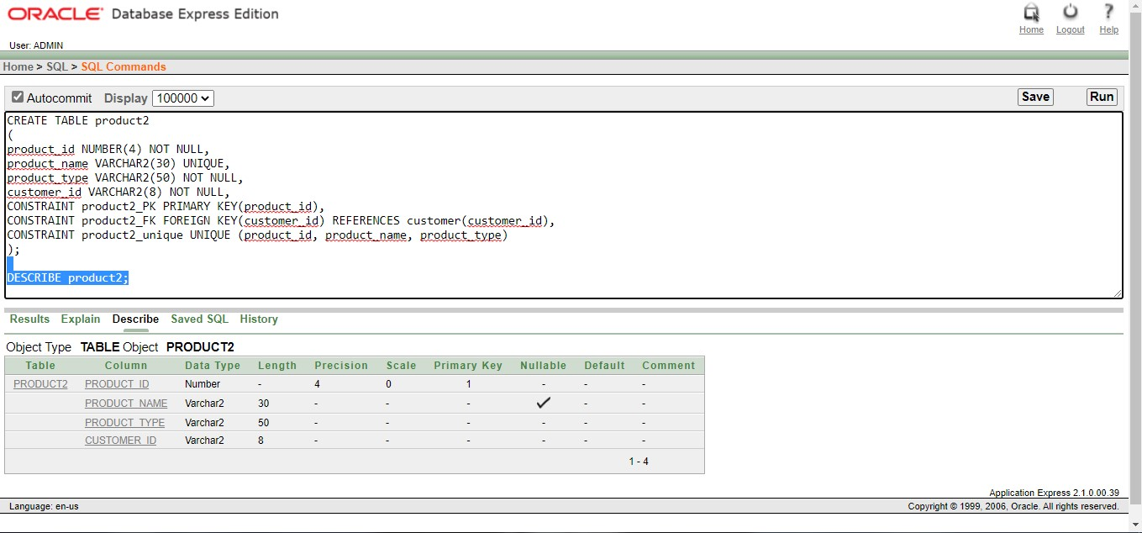

**Table : cart**

CREATE TABLE cart

(

cart_id NUMBER(4) PRIMARY KEY,

product_id NUMBER(4) UNIQUE,

serial_id NUMBER(4) NOT NULL,

customer_id VARCHAR2(8) NOT NULL,

pq_id NUMBER(38),

CONSTRAINT cart_c_FK FOREIGN KEY(customer_id) REFERENCES customer(customer_id),

CONSTRAINT cart_pq_FK FOREIGN KEY(pq_id) REFERENCES pqid(pq_id),

CONSTRAINT cart_unique UNIQUE (serial_id, customer_id, cart_id)

);

DESCRIBE cart;

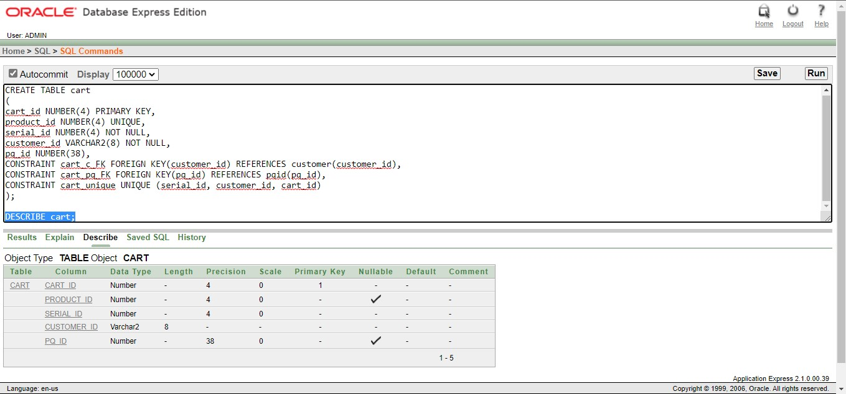

**Table : pqid**

CREATE TABLE pqid

(

pq_id NUMBER(4) PRIMARY KEY,

price NUMBER(38) NOT NULL,

quantity NUMBER(38) NOT NULL,

total_cost NUMBER(38) NOT NULL

);

DESCRIBE pqid;

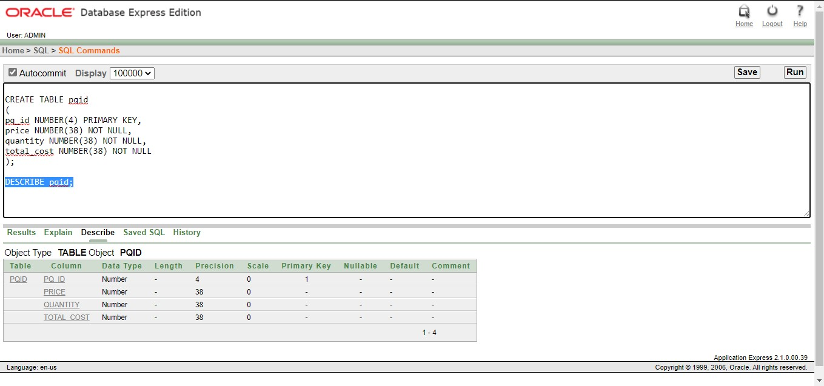

**Table : payment**

CREATE TABLE payment

(

payment_id NUMBER(4) NOT NULL,

card NUMBER(15),

amount NUMBER(10) NOT NULL,

customer_id VARCHAR2(8) NOT NULL,

cash_on_delivary VARCHAR2(8) NOT NULL,

CONSTRAINT payment_PK PRIMARY KEY(payment_id),

CONSTRAINT payment_FK FOREIGN KEY(customer_id) REFERENCES customer(customer_id),

CONSTRAINT payment_unique UNIQUE (payment_id, customer_id)

);

DESCRIBE payment;

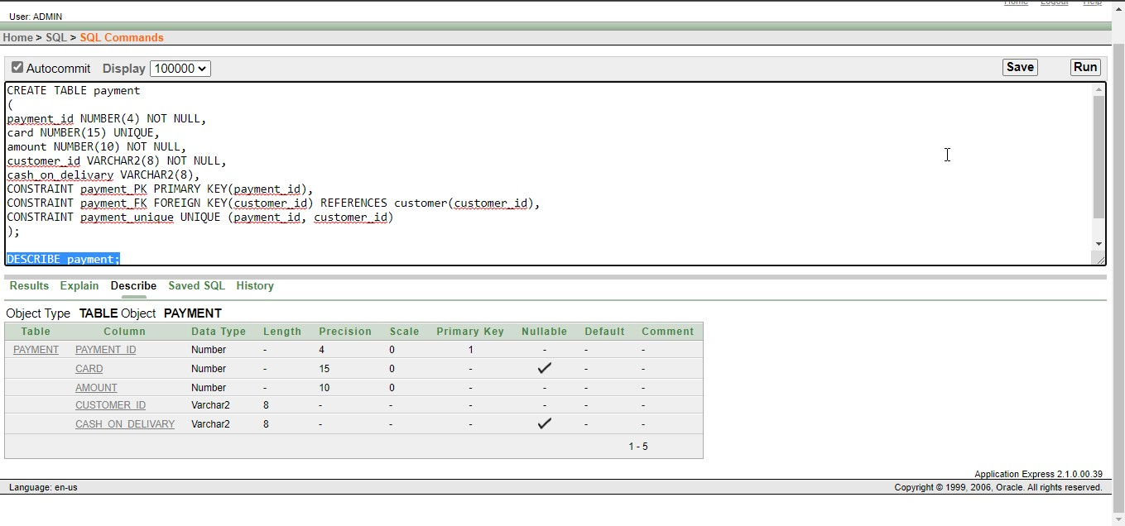

**Table : order1**

CREATE TABLE order1

(

order_id NUMBER(4) NOT NULL,

total_cost NUMBER(15) NOT NULL,

product_id NUMBER(4) NOT NULL,

date_of_order DATE,

customer_id VARCHAR2(8) NOT NULL,

CONSTRAINT order1_PK PRIMARY KEY(order_id),

CONSTRAINT order1_FK FOREIGN KEY(customer_id) REFERENCES customer(customer_id),

CONSTRAINT order1_unique UNIQUE (order_id, customer_id, product_id)

);

DESCRIBE order1;

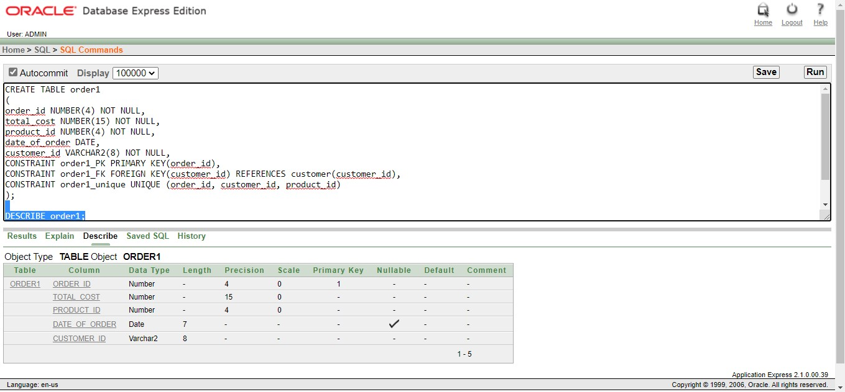

**Table : product3**

CREATE TABLE product3

(

product_id NUMBER(4) NOT NULL,

product_name VARCHAR2(30) UNIQUE,

product_type VARCHAR2(50) NOT NULL,

cart_id NUMBER(4) NOT NULL,

CONSTRAINT product3_PK PRIMARY KEY(product_id),

CONSTRAINT product3_FK FOREIGN KEY(cart_id) REFERENCES cart(cart_id),

CONSTRAINT product3_unique UNIQUE (product_id, product_type, cart_id)

);

DESCRIBE product3;

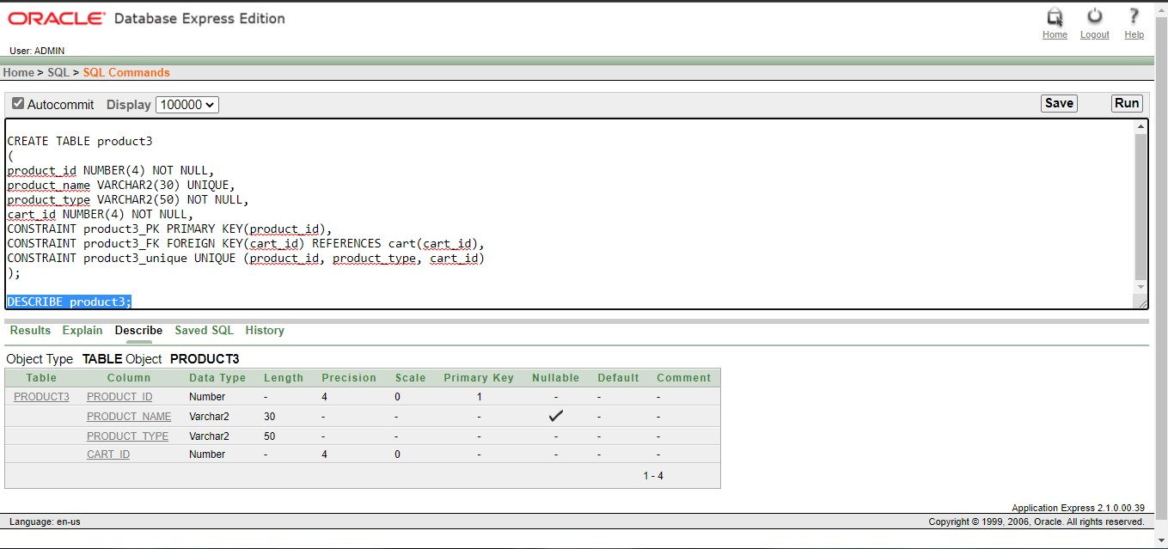

**Table : order2**

CREATE TABLE order2

(

payment_id NUMBER(4) NOT NULL,

card NUMBER(15),

amount NUMBER(10) NOT NULL,

order_id NUMBER(4) NOT NULL,

cash_on_delivary VARCHAR2(8),

CONSTRAINT payment2_PK PRIMARY KEY(payment_id),

CONSTRAINT payment2_FK FOREIGN KEY(order_id) REFERENCES order1(order_id),

CONSTRAINT payment2_unique UNIQUE (payment_id, order_id)

);

DESCRIBE order2;

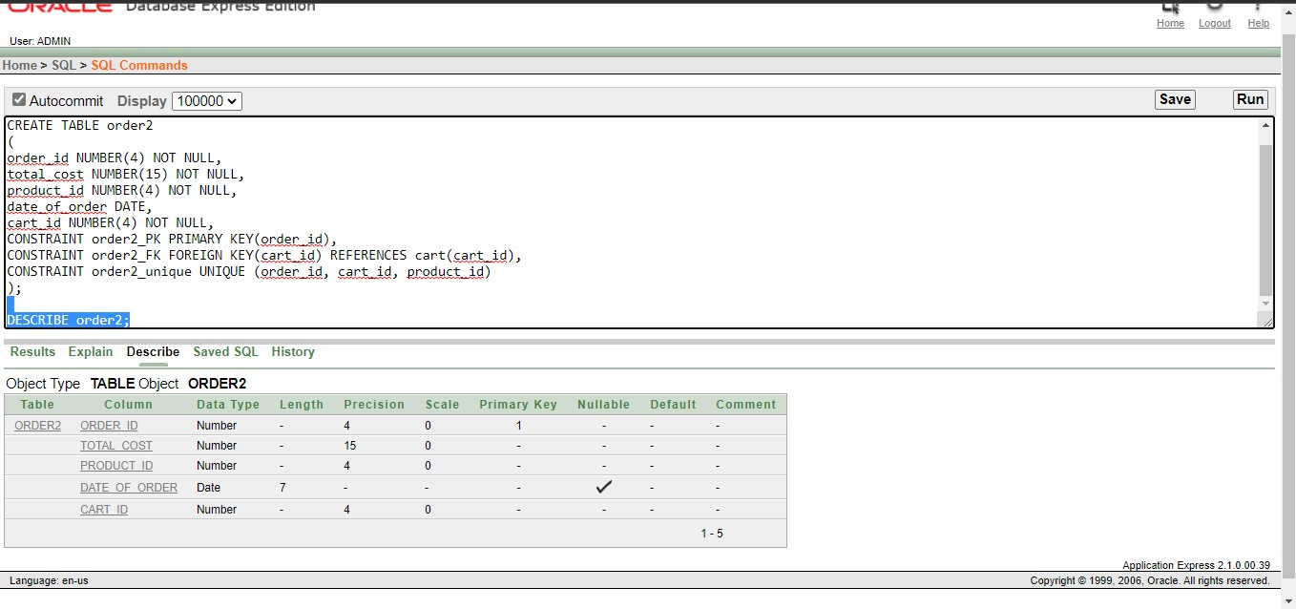

**Table : payment2**

CREATE TABLE payment2

(

payment_id NUMBER(4) NOT NULL,

card NUMBER(15),

amount NUMBER(10) NOT NULL,

order_id VARCHAR2(8) NOT NULL,

cash_on_delivary VARCHAR2(8) NOT NULL,

CONSTRAINT payment2_PK PRIMARY KEY(payment_id),

CONSTRAINT payment2_FK FOREIGN KEY(order_id) REFERENCES order1(order_id),

CONSTRAINT payment2_unique UNIQUE (payment_id, order_id)

);

DESCRIBE payment2;

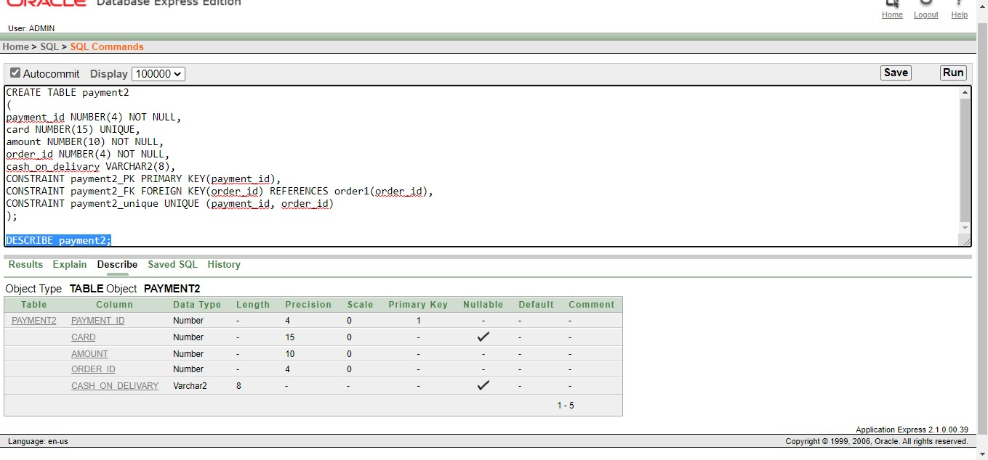

# Data Insertion

1. **admin**

INSERT INTO admin(admin_id, admin_name, admin_password, admin_phone_no, address_id) VALUES('admin', 'alex', 'admin1234', '0170000000', 01);

select * from admin

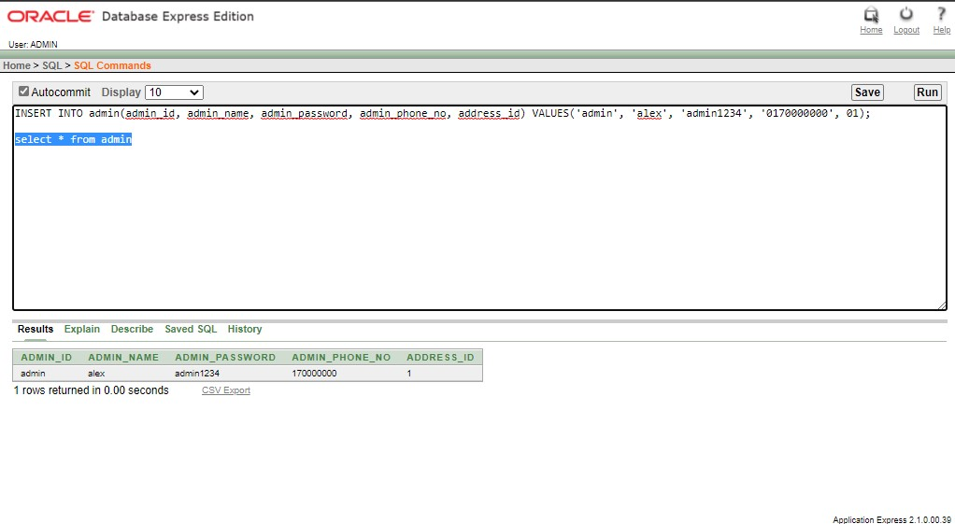

1. **address**

INSERT INTO address (address_id, admin_email, admin_address) VALUES (01, 'admin@gmail.com', 'Dhaka,Bangladesh');

select * from address;

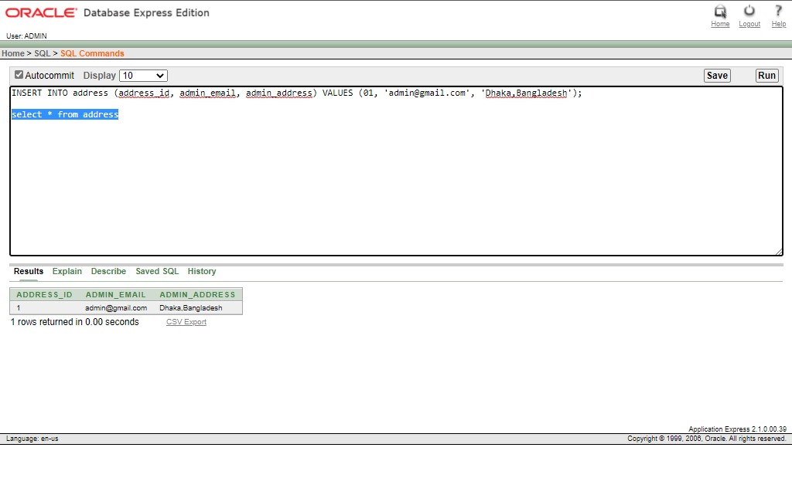

1. **product**

INSERT INTO product (product_id, product_name, product_type, admin_id) VALUES (001, 'Android Mobile', 'Gadget', 'admin');

INSERT INTO product (product_id, product_name, product_type, admin_id) VALUES (002, 'Core i7 Laptop', 'Gadget', 'admin');

INSERT INTO product (product_id, product_name, product_type, admin_id) VALUES (003, 'Mens Casual Shirt', 'Fashion', 'admin');

INSERT INTO product (product_id, product_name, product_type, admin_id) VALUES (004, 'Mens Formal Pant', 'Fashion', 'admin');

INSERT INTO product (product_id, product_name, product_type, admin_id) VALUES (005, ' Oracle Database 12c Book', 'Stationary', 'admin');

INSERT INTO product (product_id, product_name, product_type, admin_id) VALUES (006, 'Lip Stick', 'Cosmetics', 'admin');

INSERT INTO product (product_id, product_name, product_type, admin_id) VALUES (007, 'Body Lotion', 'Cosmetics', 'admin');

INSERT INTO product (product_id, product_name, product_type, admin_id) VALUES (008, 'Rice', 'Glossary', 'admin');

INSERT INTO product (product_id, product_name, product_type, admin_id) VALUES (009, 'Flour', 'Glossary', 'admin');

INSERT INTO product (product_id, product_name, product_type, admin_id) VALUES (010, 'Soyabean Oil', 'Glossary', 'admin');

select * from product;

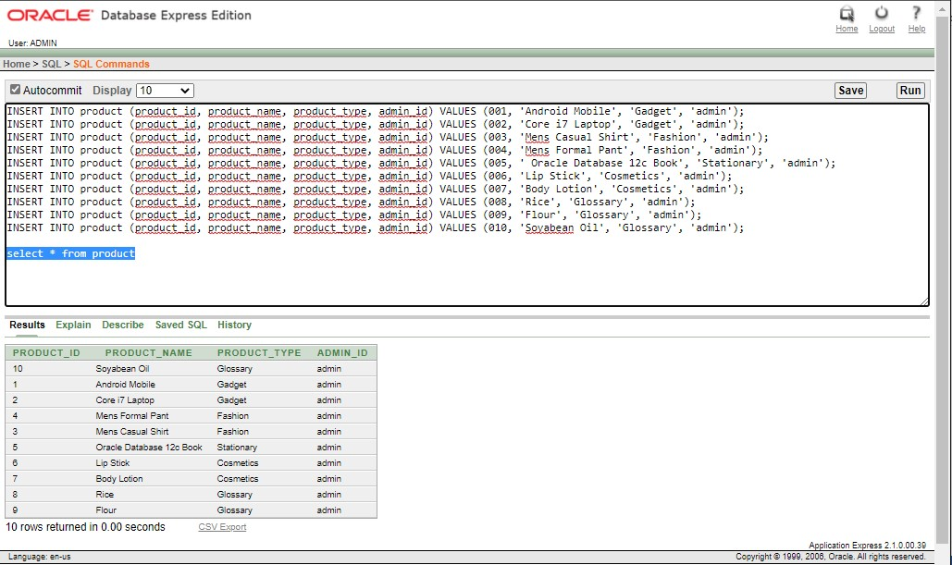

1. **category**

INSERT INTO category (category_id, category_name) VALUES (011, 'Mobile Phone');

INSERT INTO category (category_id, category_name) VALUES (012, 'Laptop');

INSERT INTO category (category_id, category_name) VALUES (013, 'Dress');

INSERT INTO category (category_id, category_name) VALUES (014, 'Pants');

INSERT INTO category (category_id, category_name) VALUES (015, 'Books');

INSERT INTO category (category_id, category_name) VALUES (016, 'Cosmetics');

INSERT INTO category (category_id, category_name) VALUES (017, 'Cosmetics-liquid');

INSERT INTO category (category_id, category_name) VALUES (018, 'Glossary-paddy');

INSERT INTO category (category_id, category_name) VALUES (019, 'Glossary-meal');

INSERT INTO category (category_id, category_name) VALUES (020, 'Glossary-oil');

select * from category;

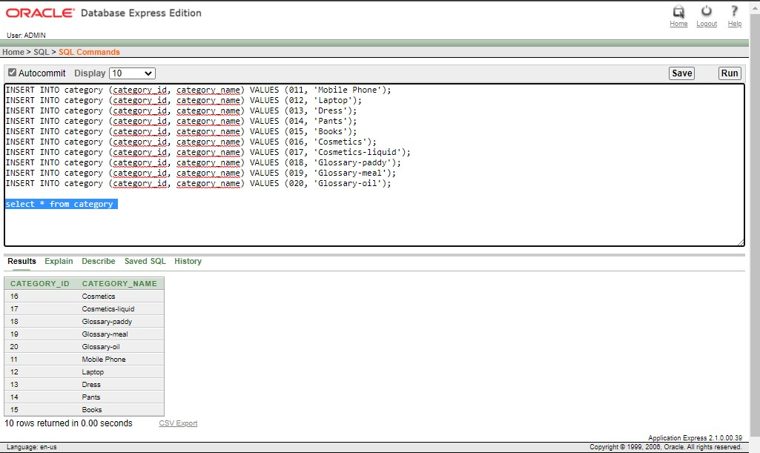

1. **pcid**

INSERT INTO pcid (product_id, category_id) VALUES (001, 011);

INSERT INTO pcid (product_id, category_id) VALUES (002, 012);

INSERT INTO pcid (product_id, category_id) VALUES (003, 013);

INSERT INTO pcid (product_id, category_id) VALUES (004, 014);

INSERT INTO pcid (product_id, category_id) VALUES (005, 015);

INSERT INTO pcid (product_id, category_id) VALUES (006, 016);

INSERT INTO pcid (product_id, category_id) VALUES (007, 017);

INSERT INTO pcid (product_id, category_id) VALUES (008, 018);

INSERT INTO pcid (product_id, category_id) VALUES (009, 019);

INSERT INTO pcid (product_id, category_id) VALUES (010, 020);

select * from pcid;

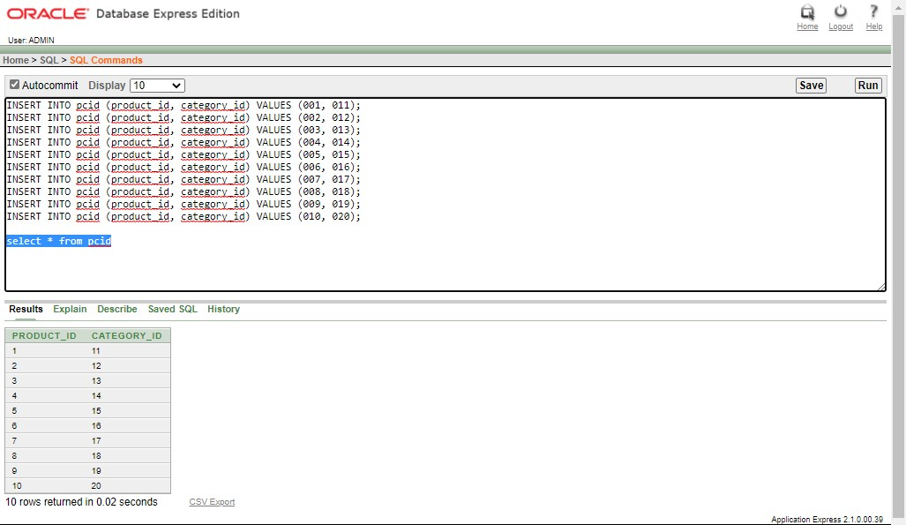

1. **brand**

INSERT INTO brand (brand_id, brand_name) VALUES (111, 'Samsung');

INSERT INTO brand (brand_id, brand_name) VALUES (112, 'ASUS');

INSERT INTO brand (brand_id, brand_name) VALUES (113, 'Yellow');

INSERT INTO brand (brand_id, brand_name) VALUES (114, 'Cat’s Eye');

INSERT INTO brand (brand_id, brand_name) VALUES (115, 'Springer Nature');

INSERT INTO brand (brand_id, brand_name) VALUES (116, 'Lakme');

INSERT INTO brand (brand_id, brand_name) VALUES (117, 'Nevia');

INSERT INTO brand (brand_id, brand_name) VALUES (118, 'Pran');

INSERT INTO brand (brand_id, brand_name) VALUES (119, 'Teer');

INSERT INTO brand (brand_id, brand_name) VALUES (120, 'Fresh');

select * from brand;

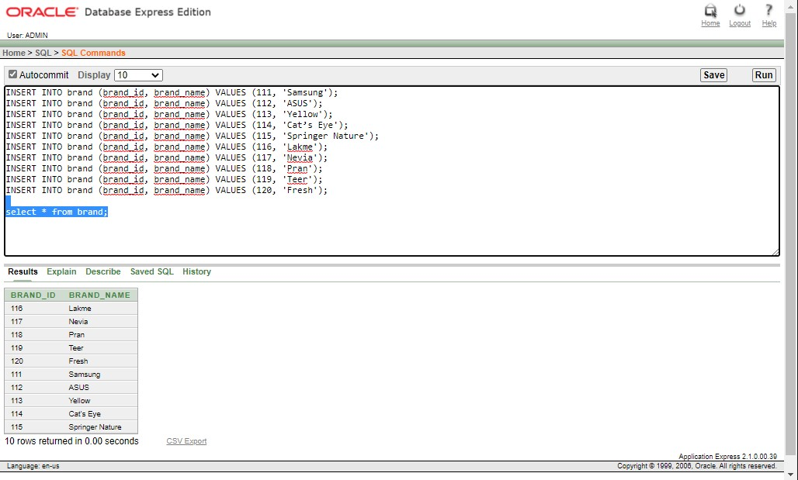

1. **cbid**

INSERT INTO cbid (category_id,brand_id) VALUES (011, 111);

INSERT INTO cbid (category_id,brand_id) VALUES (012, 112);

INSERT INTO cbid (category_id,brand_id) VALUES (013, 113);

INSERT INTO cbid (category_id,brand_id) VALUES (014, 114);

INSERT INTO cbid (category_id,brand_id) VALUES (015, 115);

INSERT INTO cbid (category_id,brand_id) VALUES (016, 116);

INSERT INTO cbid (category_id,brand_id) VALUES (017, 117);

INSERT INTO cbid (category_id,brand_id) VALUES (018, 118);

INSERT INTO cbid (category_id,brand_id) VALUES (019, 119);

INSERT INTO cbid (category_id,brand_id) VALUES (020, 120);

select * from cbid;

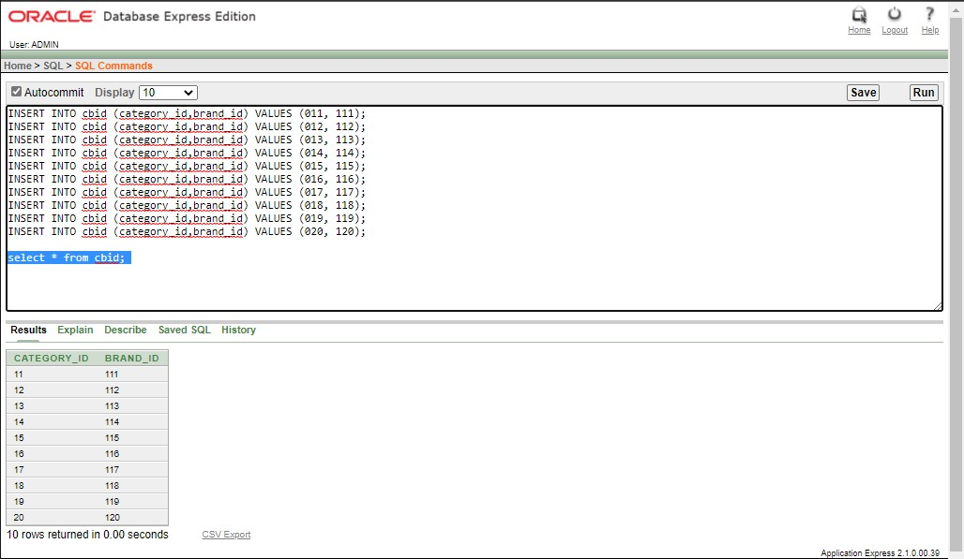

1. **customer**

INSERT INTO customer (customer_id, customer_name, customer_address, customer_phone_no, customer_username, customer_password) VALUES ('masufian', 'Md Abu Sufian', 'Uttara, Dhaka', '01700000011', 'masufian', 'abc');

INSERT INTO customer (customer_id, customer_name, customer_address, customer_phone_no, customer_username, customer_password) VALUES ('smkhan', 'Saidul Mursalin Khan', 'Dhanmondi, Dhaka', '01700000012', 'smkhan', 'abcd');

INSERT INTO customer (customer_id, customer_name, customer_address, customer_phone_no, customer_username, customer_password) VALUES ('masayeed', 'Md Abu Sayeed', 'Nikunja, Dhaka', '01700000013', 'masayeed', 'abcde');

INSERT INTO customer (customer_id, customer_name, customer_address, customer_phone_no, customer_username, customer_password) VALUES ('sksarkar', 'Sumit Kanti Sarkar', 'Kuril, Dhaka', '01700000014', 'sksarkar', 'abcdef');

INSERT INTO customer (customer_id, customer_name, customer_address, customer_phone_no, customer_username, customer_password) VALUES ('aira', 'Abzana Ira', 'Bashundhara, Dhaka', '01700000015', 'aera', 'abcdefg');

INSERT INTO customer (customer_id, customer_name, customer_address, customer_phone_no, customer_username, customer_password) VALUES ('dwarner', 'David Warner', 'Mirpur,Dhaka', 01700000016, 'dwarner', 'abcdefgh');

INSERT INTO customer (customer_id, customer_name, customer_address, customer_phone_no, customer_username, customer_password) VALUES ('hamla', 'Hasim Amla', 'Bashundhara,Dhaka', 01700000017, 'hamla', 'abcdefghi');

INSERT INTO customer (customer_id, customer_name, customer_address, customer_phone_no, customer_username, customer_password) VALUES ('mali', 'Moien Ali', 'Banani,Dhaka', 01700000018, 'mali', 'abcdefghij');

INSERT INTO customer (customer_id, customer_name, customer_address, customer_phone_no, customer_username, customer_password) VALUES ('sali', 'Saif Ali', 'Baridhara,Dhaka', 01700000019, 'sali', 'abcdefghijk');

INSERT INTO customer (customer_id, customer_name, customer_address, customer_phone_no, customer_username, customer_password) VALUES ('niqbal', 'Nafis Iqbal', 'Gulshan,Dhaka', 01700000020, 'niqbal', 'abcdefghijkl');

select * from customer;

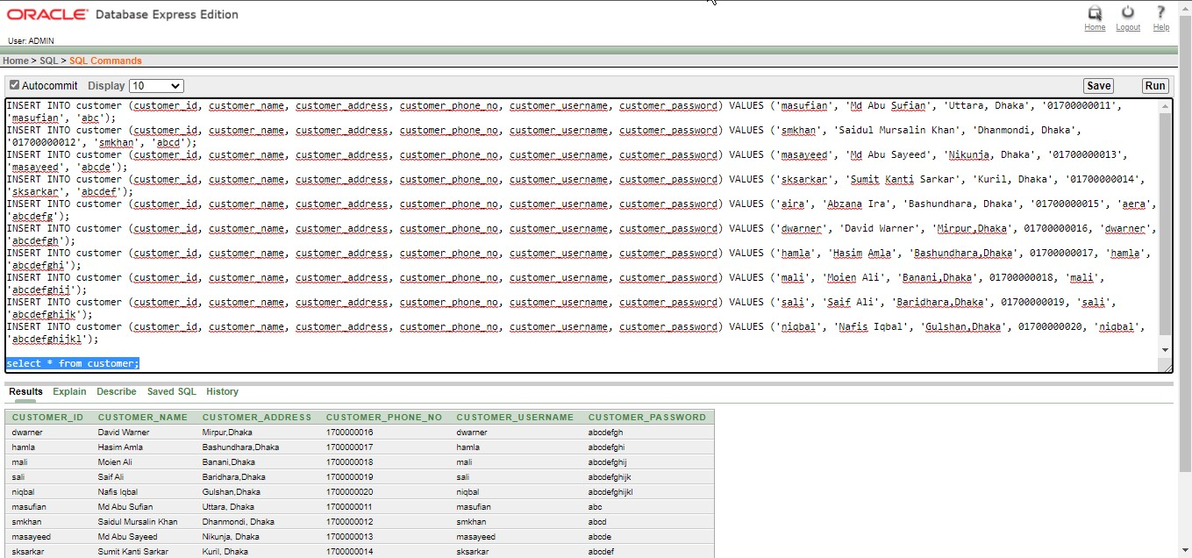

1. **wishlist**

INSERT INTO wishlist (wishlist_id, product_id, customer_id) VALUES (121, 001, 'masufian');

INSERT INTO wishlist (wishlist_id, product_id, customer_id) VALUES (122, 002, 'smkhan');

INSERT INTO wishlist (wishlist_id, product_id, customer_id) VALUES (123, 003, 'masayeed');

INSERT INTO wishlist (wishlist_id, product_id, customer_id) VALUES (124, 004, 'sksarkar');

INSERT INTO wishlist (wishlist_id, product_id, customer_id) VALUES (125, 005, 'aira');

INSERT INTO wishlist (wishlist_id, product_id, customer_id) VALUES (126, 006, 'dwarner');

INSERT INTO wishlist (wishlist_id, product_id, customer_id) VALUES (127, 007, 'hamla');

INSERT INTO wishlist (wishlist_id, product_id, customer_id) VALUES (128, 008, 'mali');

INSERT INTO wishlist (wishlist_id, product_id, customer_id) VALUES (129, 009, 'sali');

INSERT INTO wishlist (wishlist_id, product_id, customer_id) VALUES (130, 010, 'niqbal');

select * from wishlist;

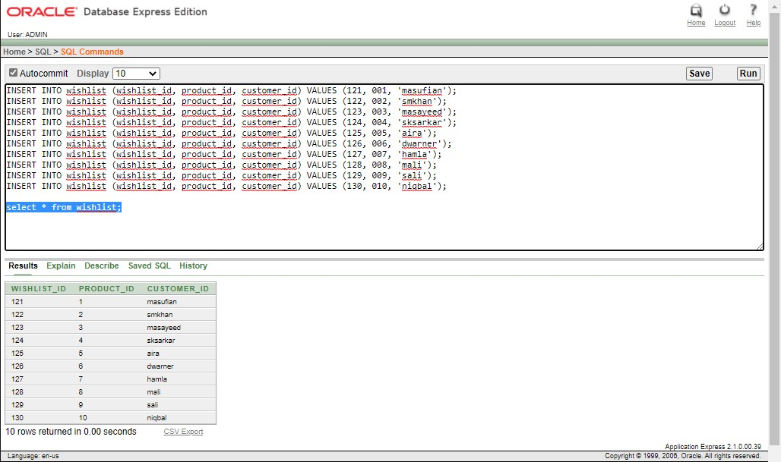

1. **product2**

INSERT INTO product2 (product_id, product_name, product_type, customer_id) VALUES (001, 'Android Mobile', 'Gadget', 'masufian');

INSERT INTO product2 (product_id, product_name, product_type, customer_id) VALUES (002, 'Core i7 Laptop', 'Gadget', 'smkhan');

INSERT INTO product2 (product_id, product_name, product_type, customer_id) VALUES (003, 'Mens Casual Shirt', 'Fashion', 'masayeed');

INSERT INTO product2 (product_id, product_name, product_type, customer_id) VALUES (004, 'Mens Formal Pant', 'Fashion', 'sksarkar');

INSERT INTO product2 (product_id, product_name, product_type, customer_id) VALUES (005, 'Oracle Database 12c Book', 'Stationary', 'aira');

INSERT INTO product2 (product_id, product_name, product_type, customer_id) VALUES (006, 'Lip Stick', 'Cosmetics', 'dwarner');

INSERT INTO product2 (product_id, product_name, product_type, customer_id) VALUES (007, 'Body Lotion', 'Cosmetics', 'hamla');

INSERT INTO product2 (product_id, product_name, product_type, customer_id) VALUES (008, 'Rice', 'Glossary', 'mali');

INSERT INTO product2 (product_id, product_name, product_type, customer_id) VALUES (009, 'Flour', 'Glossary', 'sali');

INSERT INTO product2 (product_id, product_name, product_type, customer_id) VALUES (010, 'Soyabean Oil', 'Glossary', 'niqbal');

select * from product2

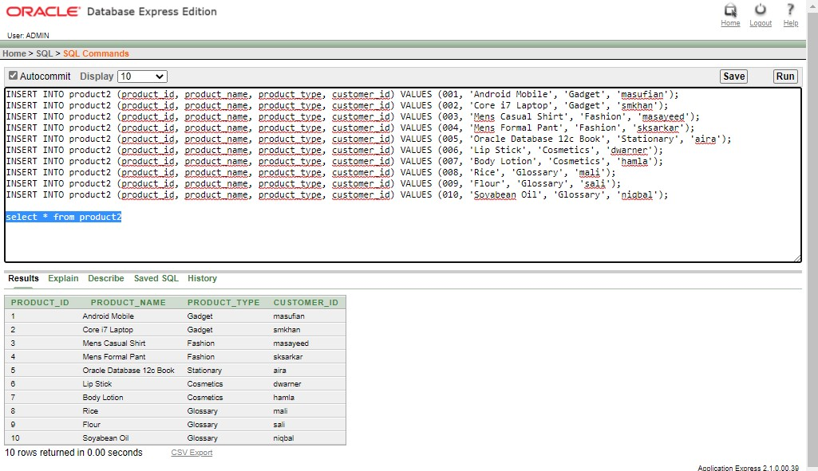

1. **Cart**

INSERT INTO cart (cart_id, product_id, serial_id, customer_id, pq_id) VALUES (131, 001, 141, 'masufian', 151);

INSERT INTO cart (cart_id, product_id, serial_id, customer_id, pq_id) VALUES (132, 002, 142, 'smkhan', 152);

INSERT INTO cart (cart_id, product_id, serial_id, customer_id, pq_id) VALUES (133, 003, 143, 'masayeed', 153);

INSERT INTO cart (cart_id, product_id, serial_id, customer_id, pq_id) VALUES (134, 004, 144, 'sksarkar', 154);

INSERT INTO cart (cart_id, product_id, serial_id, customer_id, pq_id) VALUES (135, 005, 145, 'aira', 155);

INSERT INTO cart (cart_id, product_id, serial_id, customer_id, pq_id) VALUES (136, 006, 146, 'dawarner', 156);

INSERT INTO cart (cart_id, product_id, serial_id, customer_id, pq_id) VALUES (137, 007, 147, 'hamla', 157);

INSERT INTO cart (cart_id, product_id, serial_id, customer_id, pq_id) VALUES (138, 008, 148, 'mali', 158);

INSERT INTO cart (cart_id, product_id, serial_id, customer_id, pq_id) VALUES (139, 009, 149, 'sali', 159);

INSERT INTO cart (cart_id, product_id, serial_id, customer_id, pq_id) VALUES (140, 010, 150, 'niqbal', 160);

select * from cart;

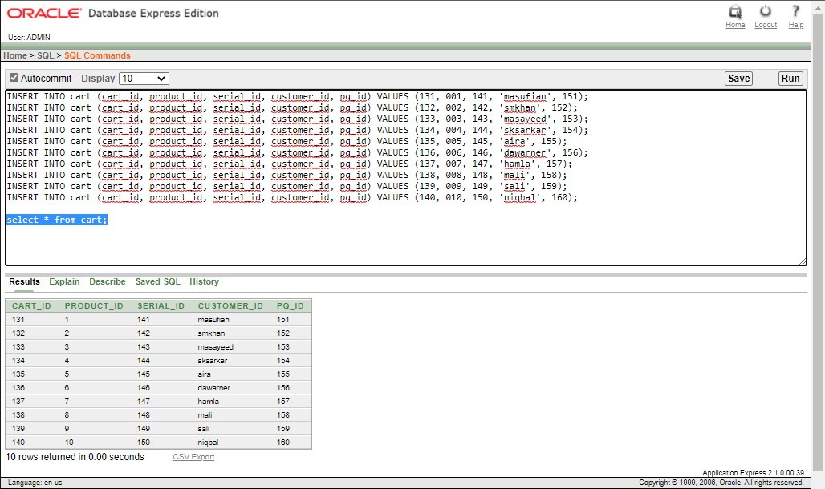

1. **pqid**

INSERT INTO pqid (pq_id, price, quantity, total_cost) VALUES (151, 20000, 01, 20000);

INSERT INTO pqid (pq_id, price, quantity, total_cost) VALUES (152, 65000, 01, 65000);

INSERT INTO pqid (pq_id, price, quantity, total_cost) VALUES (153, 1750, 03, 5250);

INSERT INTO pqid (pq_id, price, quantity, total_cost) VALUES (154, 1190, 03, 3570);

INSERT INTO pqid (pq_id, price, quantity, total_cost) VALUES (155, 450, 05, 2250);

INSERT INTO pqid (pq_id, price, quantity, total_cost) VALUES (156, 900, 01, 900);

INSERT INTO pqid (pq_id, price, quantity, total_cost) VALUES (157, 550, 02, 1100);

INSERT INTO pqid (pq_id, price, quantity, total_cost) VALUES (158, 55, 05, 275);

INSERT INTO pqid (pq_id, price, quantity, total_cost) VALUES (159, 46, 02, 92);

INSERT INTO pqid (pq_id, price, quantity, total_cost) VALUES (160, 105, 05, 525);

select * from pqid

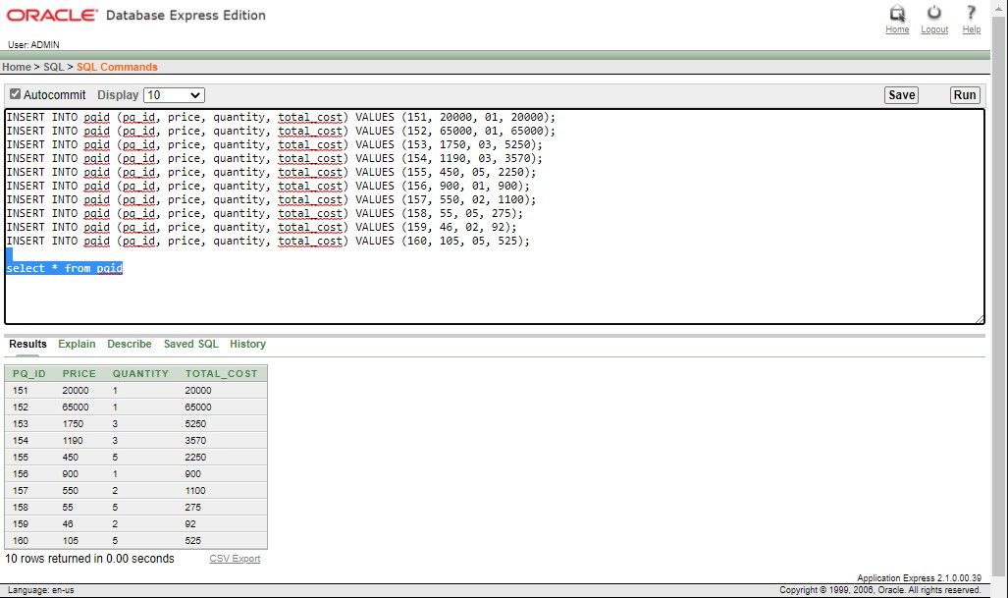

1. **payment**

INSERT INTO payment (payment_id, card, amount, customer_id, cash_on_delivary) VALUES (5551, 21541202, 20000, 'masufian', 'No');

INSERT INTO payment (payment_id, card, amount, customer_id, cash_on_delivary) VALUES (5552, 00, 65000, 'smkhan', 'Yes');

INSERT INTO payment (payment_id, card, amount, customer_id, cash_on_delivary) VALUES (5553, 4154874, 5250, 'masayeed', 'No');

INSERT INTO payment (payment_id, card, amount, customer_id, cash_on_delivary) VALUES (5554, 00, 3570, 'sksarkar', 'Yes');

INSERT INTO payment (payment_id, card, amount, customer_id, cash_on_delivary) VALUES (5555, 0790652, 2250, 'aira', 'No');

INSERT INTO payment (payment_id, card, amount, customer_id, cash_on_delivary) VALUES (5556, 24674520, 900, 'dwarner', 'No');

INSERT INTO payment (payment_id, card, amount, customer_id, cash_on_delivary) VALUES (5557, 21541204, 1100, 'hamla', 'No');

INSERT INTO payment (payment_id, card, amount, customer_id, cash_on_delivary) VALUES (5558, 00, 275, 'mali', 'Yes');

INSERT INTO payment (payment_id, card, amount, customer_id, cash_on_delivary) VALUES (5559, 54251525, 92, 'sali', 'No');

INSERT INTO payment (payment_id, card, amount, customer_id, cash_on_delivary) VALUES (5560, 00, 525, 'niqbal', 'Yes');

select * from payment;

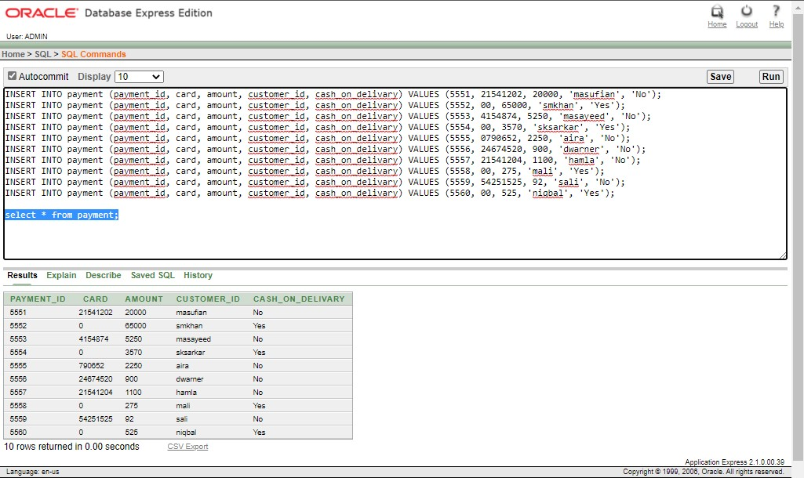

1. **order1**

INSERT INTO order1 (order_id, total_cost, product_id, date_of_order, customer_id) VALUES (0101, 20000, 001, DATE '2020-11-22', 'masufian');

INSERT INTO order1 (order_id, total_cost, product_id, date_of_order, customer_id) VALUES (0102, 65000, 002, DATE '2020-11-20', 'smkhan');

INSERT INTO order1 (order_id, total_cost, product_id, date_of_order, customer_id) VALUES (0103, 5250, 003, DATE '2020-11-10', 'masayeed');

INSERT INTO order1 (order_id, total_cost, product_id, date_of_order, customer_id) VALUES (0104, 3570, 004, DATE '2020-11-26', 'sksarkar');

INSERT INTO order1 (order_id, total_cost, product_id, date_of_order, customer_id) VALUES (0105, 2250, 005, DATE '2020-12-12', 'aira');

INSERT INTO order1 (order_id, total_cost, product_id, date_of_order, customer_id) VALUES (0106, 900, 006, DATE '2020-12-11', 'dwarner');

INSERT INTO order1 (order_id, total_cost, product_id, date_of_order, customer_id) VALUES (0107, 1100, 007, DATE '2020-12-11', 'hamla');

INSERT INTO order1 (order_id, total_cost, product_id, date_of_order, customer_id) VALUES (0108, 275, 008, DATE '2020-12-17', 'mali');

INSERT INTO order1 (order_id, total_cost, product_id, date_of_order, customer_id) VALUES (0109, 92, 009, DATE '2020-12-5', 'sali');

INSERT INTO order1 (order_id, total_cost, product_id, date_of_order, customer_id) VALUES (0110, 525, 010, DATE '2020-12-4', 'niqbal');

select * from order1;

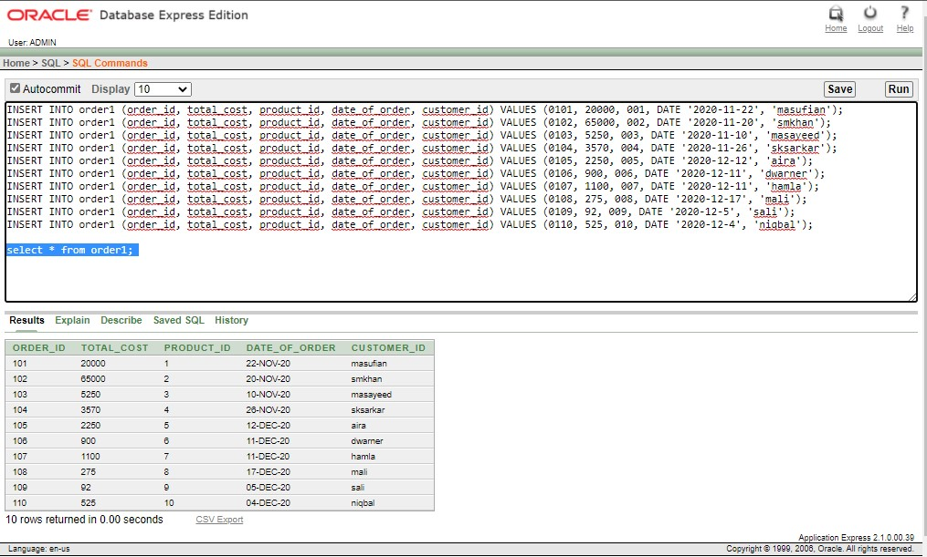

1. **product3**

INSERT INTO product3 (product_id, product_name, product_type, cart_id) VALUES (001, 'Android Mobile', 'Gadget', 131);

INSERT INTO product3 (product_id, product_name, product_type, cart_id) VALUES (002, 'Core i7 Laptop', 'Gadget', 132);

INSERT INTO product3 (product_id, product_name, product_type, cart_id) VALUES (003, 'Mens Casual Shirt', 'Fashion', 133);

INSERT INTO product3 (product_id, product_name, product_type, cart_id) VALUES (004, 'Mens Formal Pant', 'Fashion', 134);

INSERT INTO product3 (product_id, product_name, product_type, cart_id) VALUES (005, 'Oracle Database 12c Book', 'Stationary', 135);

INSERT INTO product3 (product_id, product_name, product_type, cart_id) VALUES (006, 'Lip Stick', 'Cosmetics', 136);

INSERT INTO product3 (product_id, product_name, product_type, cart_id) VALUES (007, 'Body Lotion', 'Cosmetics', 137);

INSERT INTO product3 (product_id, product_name, product_type, cart_id) VALUES (008, 'Rice', 'Glossary', 138);

INSERT INTO product3 (product_id, product_name, product_type, cart_id) VALUES (009, 'Flour', 'Glossary', 139);

INSERT INTO product3 (product_id, product_name, product_type, cart_id) VALUES (010, 'Soyabean Oil', 'Glossary', 140);

select * from product3;

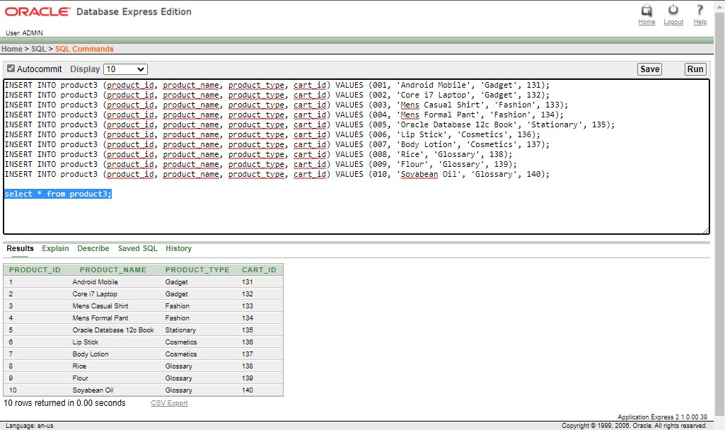

1. **order2**

INSERT INTO order2 (order_id, total_cost, product_id, date_of_order, cart_id) VALUES (0101, 20000, 001, DATE '2020-11-22', 131);

INSERT INTO order2 (order_id, total_cost, product_id, date_of_order, cart_id) VALUES (0102, 65000, 002, DATE '2020-11-20', 132);

INSERT INTO order2 (order_id, total_cost, product_id, date_of_order, cart_id) VALUES (0103, 5250, 003, DATE '2020-11-10', 133);

INSERT INTO order2 (order_id, total_cost, product_id, date_of_order, cart_id) VALUES (0104, 3570, 004, DATE '2020-11-26', 134);

INSERT INTO order2 (order_id, total_cost, product_id, date_of_order, cart_id) VALUES (0105, 2250, 005, DATE '2020-12-12', 135);

INSERT INTO order2 (order_id, total_cost, product_id, date_of_order, cart_id) VALUES (0106, 900, 006, DATE '2020-12-11', 136);

INSERT INTO order2 (order_id, total_cost, product_id, date_of_order, cart_id) VALUES (0107, 1100, 007, DATE '2020-12-11', 137);

INSERT INTO order2 (order_id, total_cost, product_id, date_of_order, cart_id) VALUES (0108, 275, 008, DATE '2020-12-17', 138);

INSERT INTO order2 (order_id, total_cost, product_id, date_of_order, cart_id) VALUES (0109, 92, 009, DATE '2020-12-5', 139);

INSERT INTO order2 (order_id, total_cost, product_id, date_of_order, cart_id) VALUES (0110, 525, 010, DATE '2020-12-4', 140);

select * from order2;

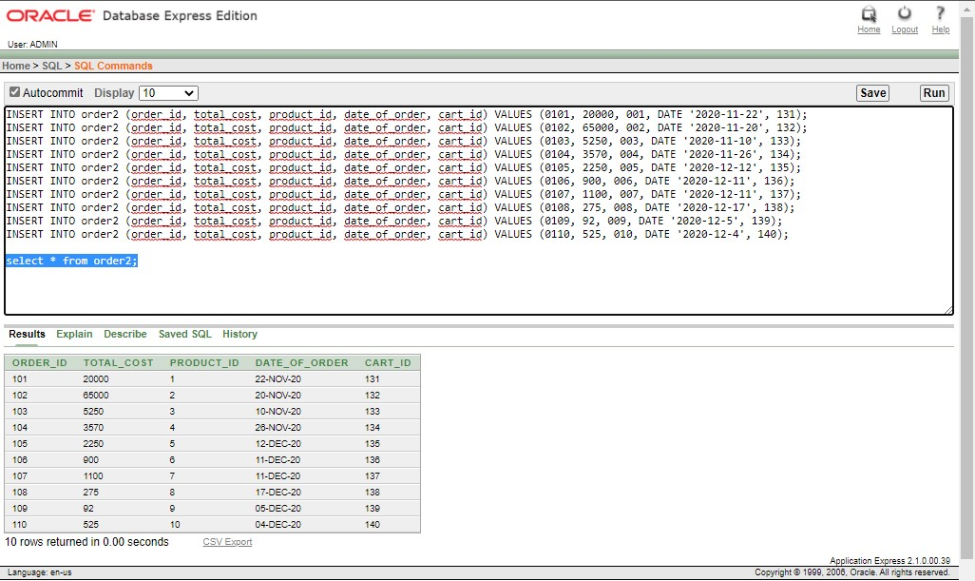

1. **payment2**

INSERT INTO payment2 (payment_id, card, amount, order_id, cash_on_delivary) VALUES (5551, 21541202, 20000, 0101, 'No');

INSERT INTO payment2 (payment_id, card, amount, order_id, cash_on_delivary) VALUES (5552, 00, 65000, 0102, 'Yes');

INSERT INTO payment2 (payment_id, card, amount, order_id, cash_on_delivary) VALUES (5553, 4154874, 5250, 0103, 'No');

INSERT INTO payment2 (payment_id, card, amount, order_id, cash_on_delivary) VALUES (5554, 00, 3570, 0104, 'Yes');

INSERT INTO payment2 (payment_id, card, amount, order_id, cash_on_delivary) VALUES (5555, 0790652, 2250, 0105, 'No');

INSERT INTO payment2 (payment_id, card, amount, order_id, cash_on_delivary) VALUES (5556, 24674520, 900, 0106, 'No');

INSERT INTO payment2 (payment_id, card, amount, order_id, cash_on_delivary) VALUES (5557, 21541204, 1100, 0107, 'No');

INSERT INTO payment2 (payment_id, card, amount, order_id, cash_on_delivary) VALUES (5558, 00, 275, 0108, 'Yes');

INSERT INTO payment2 (payment_id, card, amount, order_id, cash_on_delivary) VALUES (5559, 54251525, 92, 0109, 'No');

INSERT INTO payment2 (payment_id, card, amount, order_id, cash_on_delivary) VALUES (5560, 00, 525, 0110, 'Yes');

select * from payment2

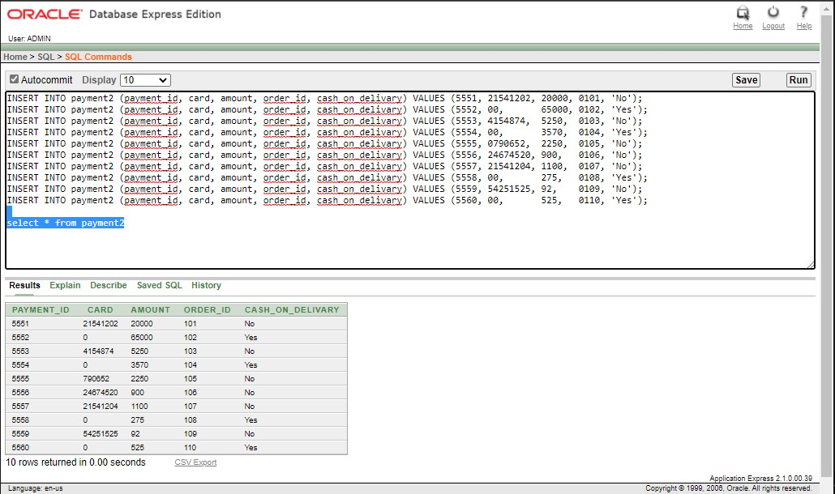

# Query Writing

1. **Sub Query**

**1-Q:**

Print the product id, product names, product type from product table where product_id is 1.

**1-A:**

select product_id, product_name, product_type from product where product_name = (select product_name from product2 where product_id=1);

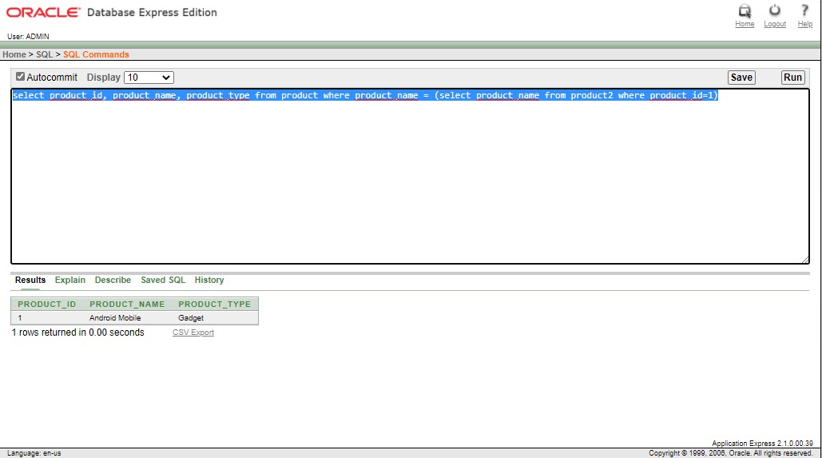

**2-Q:**

Print product id, product name, product type and cart id for cart id 131.

**2-A:**

SELECT product_id, product_name, product_type FROM product3 WHERE cart_id = (SELECT cart_id FROM cart WHERE cart_id ='131');

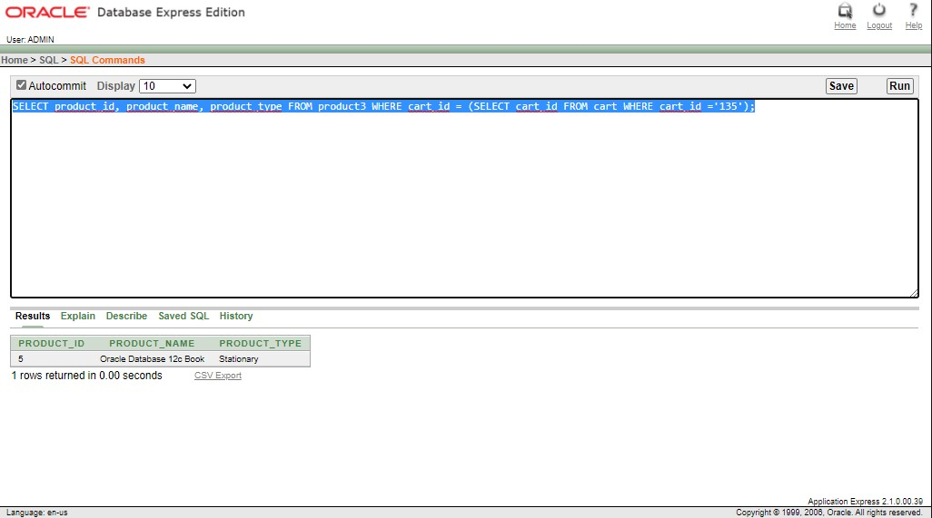

**3-Q:**

Print order id, total cost, product id, date of order, cart_id from order2 table where the total cost is greater than the cost of order which were palced on 2020-11-26.

**3-A:**

SELECT order_id, total_cost, product_id, date_of_order, cart_id FROM order2 WHERE total_cost > (SELECT AVG(total_cost) FROM order2 WHERE date_of_order=to_date('2020-11-26', 'YYYY-MM-DD'));

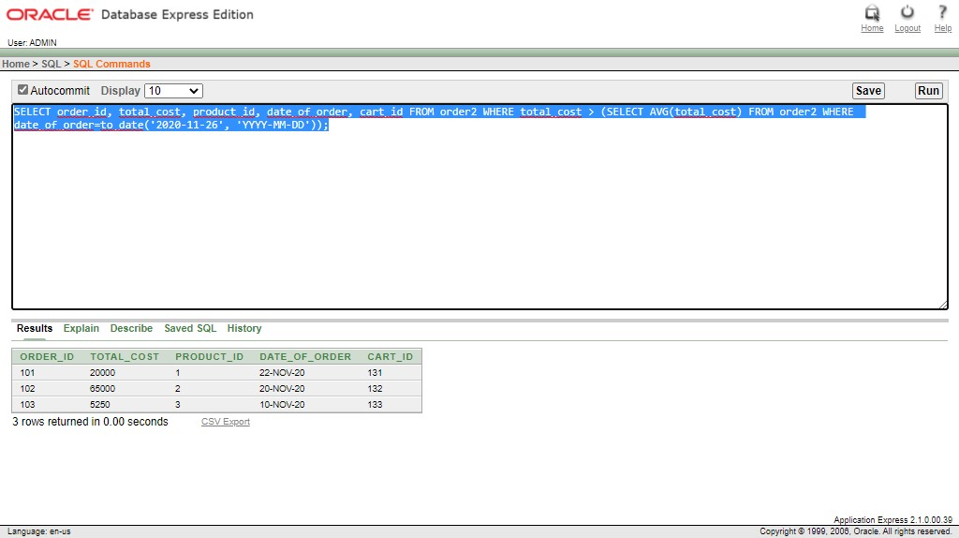

1. **Joining**

**1-Q:**

Print the admin name and admin address id by joining admin table and address table

**1-A:**

SELECT a.admin_name "Admin Name", ad.address_id "Admin Address ID" FROM admin a, address ad WHERE a.address_id = ad.address_id;

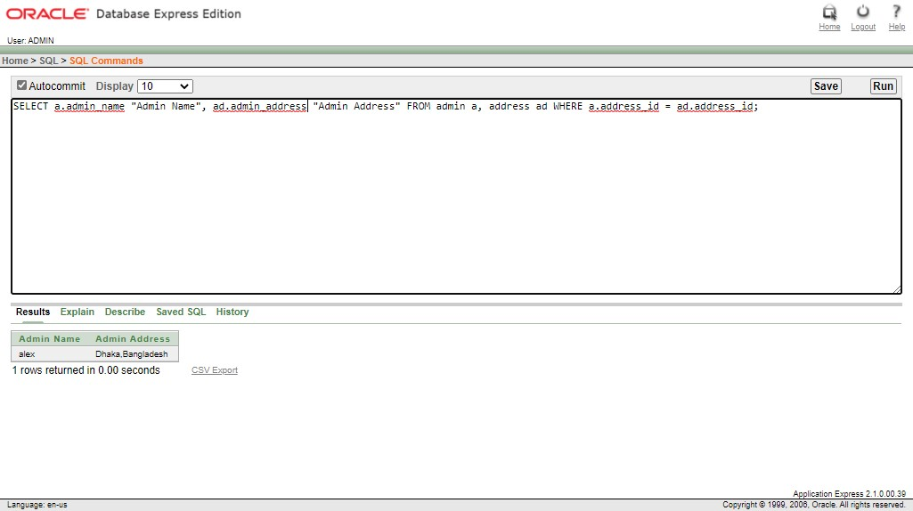

**2-Q:**

Print the customers name for customer id masufian, smkhan and aira

**2-A:**

SELECT cname.customer_name FROM customer cname, customer cid WHERE cname.customer_id = cid.customer_id AND cname.customer_id in('masufian', 'smkhan', 'aira');

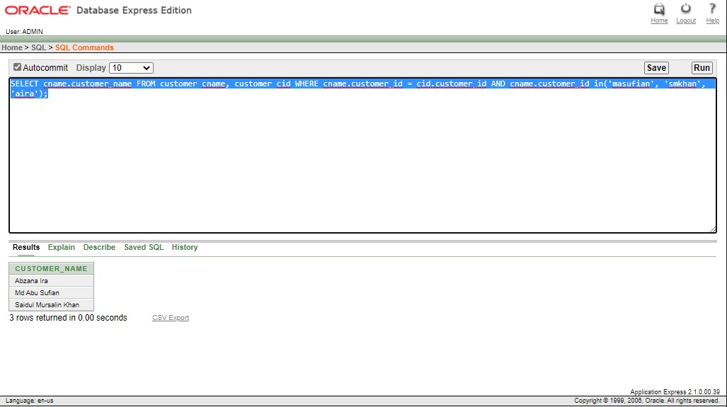

**3-Q:**

Print the customer id and count the order id from order1 table and join the customer table with order1 table.

**3-A:**

SELECT customer_id, COUNT( order_id ) FROM order1 INNER JOIN customer USING(customer_id) GROUP BY customer_id ORDER BY customer_id;

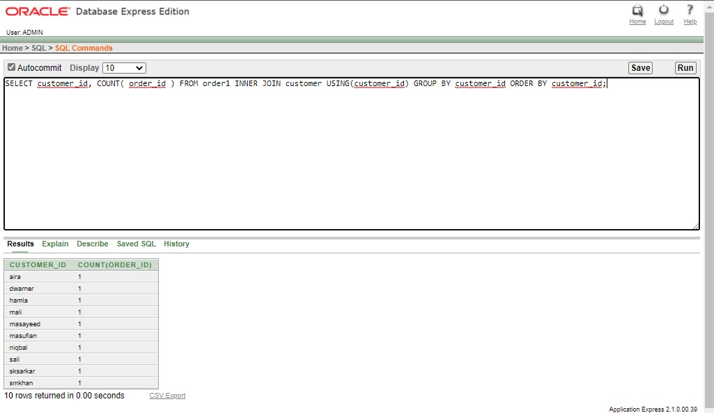

1. **Group Function**

**1-Q:**

Find average, maximum, minimum salary of the pqid.

**1-A:**

select avg(price) as average,max(price) as maximum,min(price) as minimum from pqid;

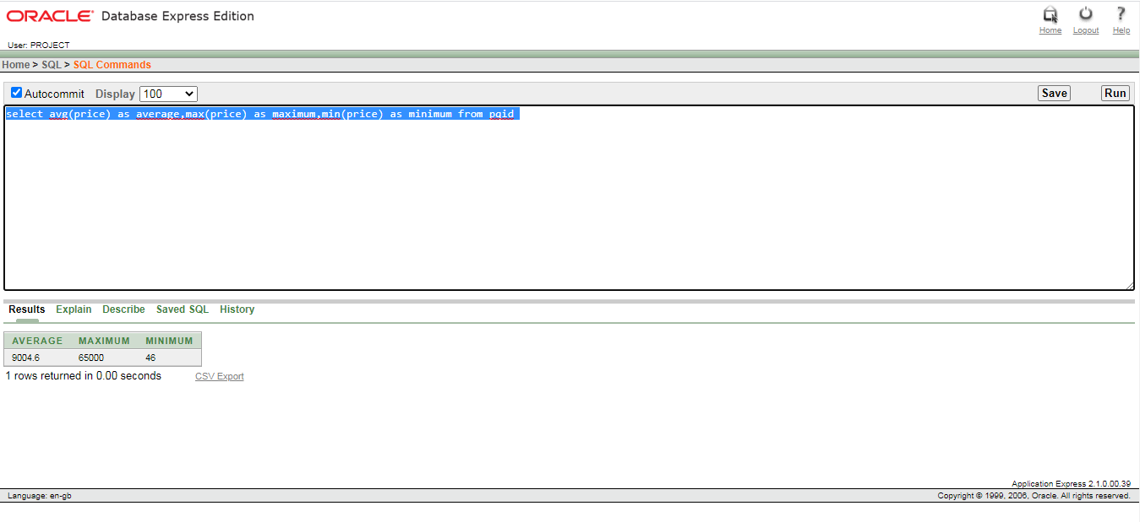

**2-Q:**

Display the maximum amount of payment2

**2-A:**

select max(amount) from payment2;

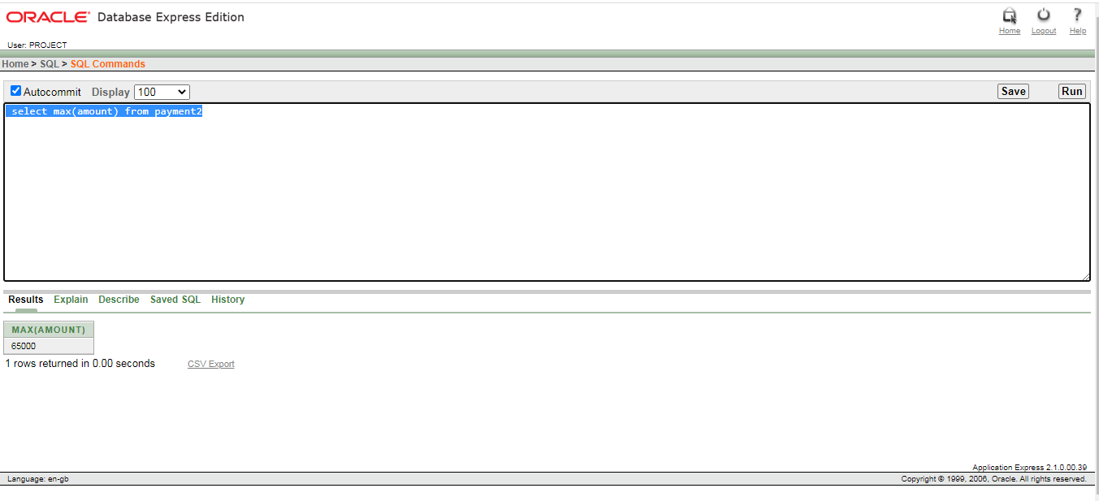

**3-Q:**

Find the number of customer who have payment <3570

**3-A:**

select count(customer_id) from payment where amount<3570;

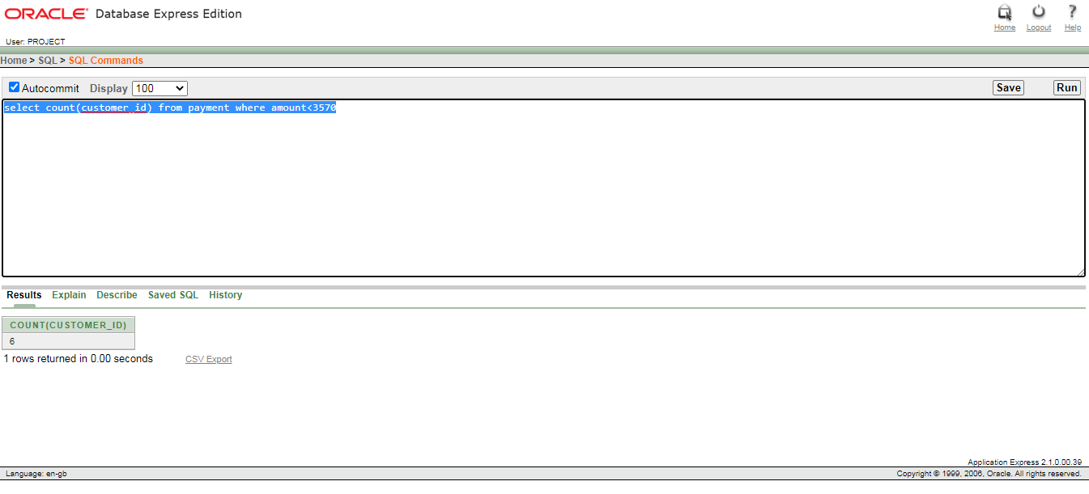

1. **Single row function**

**1-Q:**

print product, total price from order2 table and print the total cost in asending order

**1-A:**

select product_id "Product ID", TRUNC(total_cost) "Total Price" from order2 order by total_cost asc

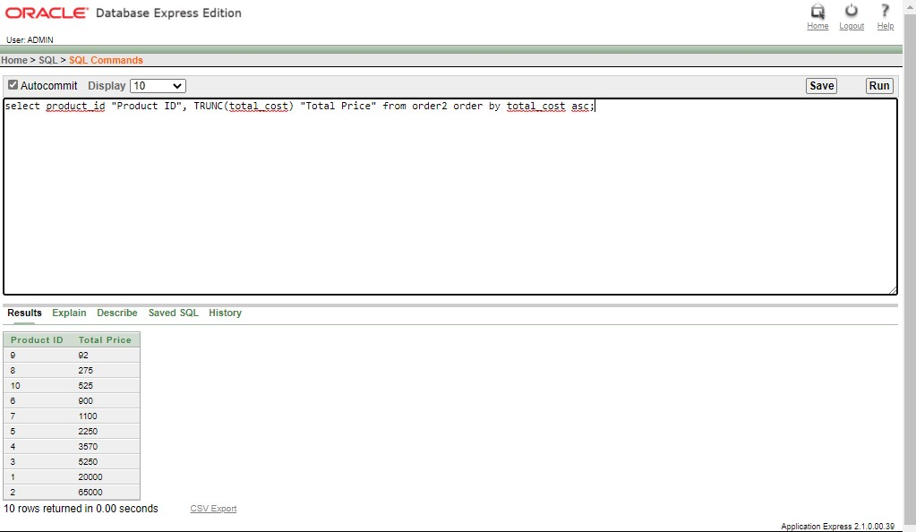

1. **View**

**1-Q:**

Create a view for customer table where we are going to print Customer ID, Customer Name, Phone Number and Address from customer table.

**1-A:**

CREATE VIEW customer_view AS

SELECT c.customer_id "Customer ID", c.customer_name "Customer Name", c.customer_phone_no "Phone Number", c.customer_address "Address" FROM customer c;

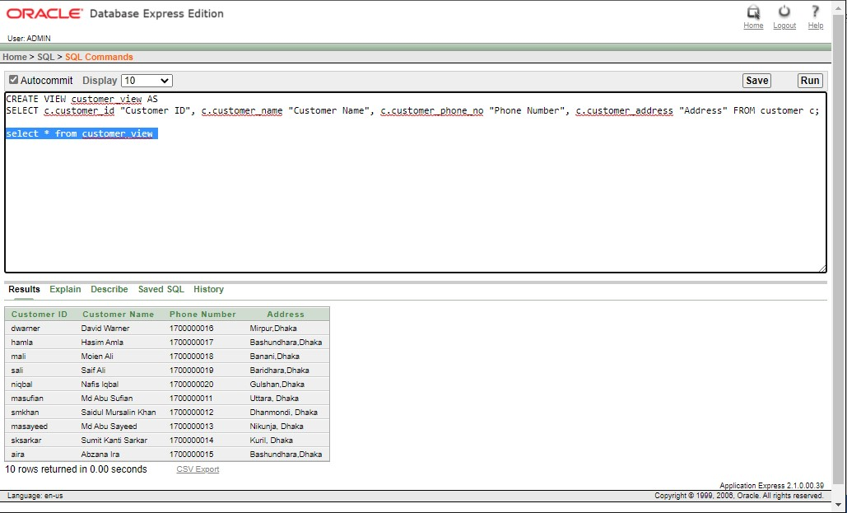

1. **Sequence**

* **Table(shipping) Create for sequence:**

CREATE TABLE shipping

(

shipping_id NUMBER(8) NOT NULL,

customer_id VARCHAR2(20) NOT NULL,

date_of_order DATE,

order_id NUMBER(4) NOT NULL,

product_id NUMBER(4) NOT NULL,

payment_id NUMBER(4) NOT NULL,

customer_address VARCHAR2(50) NOT NULL,

customer_phone_no NUMBER(11) NOT NULL,

CONSTRAINT shipping_PK PRIMARY KEY(shipping_id),

CONSTRAINT shipping_customer_FK FOREIGN KEY(customer_id) REFERENCES customer(customer_id),

CONSTRAINT shipping_order_FK FOREIGN KEY(order_id) REFERENCES order1(order_id),

CONSTRAINT shipping_product_FK FOREIGN KEY(product_id) REFERENCES product(product_id),

CONSTRAINT shipping_payment_FK FOREIGN KEY(payment_id) REFERENCES payment(payment_id),

CONSTRAINT shipping_unique UNIQUE (shipping_id, customer_id, order_id, payment_id, product_id)

);

* **Create Sequence:**

CREATE SEQUENCE shipping_id

START WITH 1230

INCREMENT BY 1

MINVALUE 1230

MAXVALUE 10000

NOCACHE

NOCYCLE;

CREATE SEQUENCE order_id

START WITH 100

INCREMENT BY 1

MINVALUE 100

MAXVALUE 10000

NOCACHE

NOCYCLE;

CREATE SEQUENCE product_id

START WITH 0

INCREMENT BY 1

MINVALUE 0

MAXVALUE 10000

NOCACHE

NOCYCLE;

CREATE SEQUENCE payment_id

START WITH 5550

INCREMENT BY 1

MINVALUE 5550

MAXVALUE 10000

NOCACHE

NOCYCLE;

* **Data Insertion in shipping table:**

INSERT INTO shipping (shipping_id, customer_id, order_id, product_id, payment_id, date_of_order, customer_phone_no, customer_address) VALUES (shipping_id.NEXTVAL, 'masufian', order_id.NEXTVAL, product_id.NEXTVAL, payment_id.NEXTVAL, DATE '2020-11-22', 01700000011, 'Uttara, Dhaka');

INSERT INTO shipping (shipping_id, customer_id, order_id, product_id, payment_id, date_of_order, customer_phone_no, customer_address) VALUES (shipping_id.NEXTVAL, 'smkhan', order_id.NEXTVAL, product_id.NEXTVAL, payment_id.NEXTVAL, DATE '2020-11-20', 01700000012, 'Dhanmondi, Dhaka');

INSERT INTO shipping (shipping_id, customer_id, order_id, product_id, payment_id, date_of_order, customer_phone_no, customer_address) VALUES (shipping_id.NEXTVAL, 'masayeed', order_id.NEXTVAL, product_id.NEXTVAL, payment_id.NEXTVAL, DATE '2020-11-10', 01700000013, 'Nikunja, Dhaka');

INSERT INTO shipping (shipping_id, customer_id, order_id, product_id, payment_id, date_of_order, customer_phone_no, customer_address) VALUES (shipping_id.NEXTVAL, 'sksarkar', order_id.NEXTVAL, product_id.NEXTVAL, payment_id.NEXTVAL, DATE '2020-11-26', 01700000014, 'Kuril, Dhaka');

INSERT INTO shipping (shipping_id, customer_id, order_id, product_id, payment_id, date_of_order, customer_phone_no, customer_address) VALUES (shipping_id.NEXTVAL, 'aira', order_id.NEXTVAL, product_id.NEXTVAL, payment_id.NEXTVAL, DATE '2020-12-12', 01700000015, 'Bashundhara, Dhaka');

INSERT INTO shipping (shipping_id, customer_id, order_id, product_id, payment_id, date_of_order, customer_phone_no, customer_address) VALUES (shipping_id.NEXTVAL, 'dwarner', order_id.NEXTVAL, product_id.NEXTVAL, payment_id.NEXTVAL, DATE '2020-12-11', 01700000016, 'Mirpur,Dhaka');

INSERT INTO shipping (shipping_id, customer_id, order_id, product_id, payment_id, date_of_order, customer_phone_no, customer_address) VALUES (shipping_id.NEXTVAL, 'hamla', order_id.NEXTVAL, product_id.NEXTVAL, payment_id.NEXTVAL, DATE '2020-12-11', 01700000017, 'Bashundhara,Dhaka');

INSERT INTO shipping (shipping_id, customer_id, order_id, product_id, payment_id, date_of_order, customer_phone_no, customer_address) VALUES (shipping_id.NEXTVAL, 'mali', order_id.NEXTVAL, product_id.NEXTVAL, payment_id.NEXTVAL, DATE '2020-12-17', 01700000018, 'Banani,Dhaka');

INSERT INTO shipping (shipping_id, customer_id, order_id, product_id, payment_id, date_of_order, customer_phone_no, customer_address) VALUES (shipping_id.NEXTVAL, 'sali', order_id.NEXTVAL, product_id.NEXTVAL, payment_id.NEXTVAL, DATE '2020-12-5', 01700000019, 'Baridhara,Dhaka');

INSERT INTO shipping (shipping_id, customer_id, order_id, product_id, payment_id, date_of_order, customer_phone_no, customer_address) VALUES (shipping_id.NEXTVAL, 'niqbal', order_id.NEXTVAL, product_id.NEXTVAL, payment_id.NEXTVAL, DATE '2020-12-4', 01700000020, 'Gulshan,Dhaka');

select * from shipping

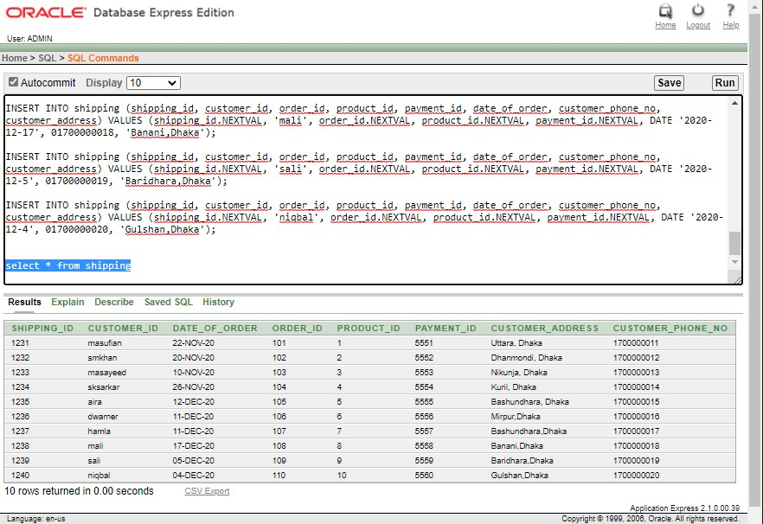

# Relational Algebra



${∏ }_{{customer}_{name}}$ ${(σ_{customer_id="smkhan" }}^{(customer)})$

${∏ }_{{product}_{name}, {product}_{type}}$ ${(σ_{product_id=5 }}^{\left(product\right)})$

${∏ }_{{categoty}_{name}}{(σ_{category_id= “15” }}^{\left(categoty\right)})$

$∏_{{a.admin}_{name}, {add.admin}_{address} }{ (σ_{{a.address}_{id}= {add.address}_{id} and a.{address}_{id}=1 }}^{\left(admin a×address add\right)})$

${∏ }_{{order}_{id}}{(σ_{date_of_order= “2020-12-12” }}^{(order1)})$

# Conclusion

Finally, successfully we have developed and implemented the E-commerce Management System with the help of Oracle Database 10g and SQL query, includes all the features which are the fundamental requirements for an E-commerce Management System.

Finally got success in our attempt to take care of the needs of both the customers as well as the administrator which was our main objective.